Phylogenomic Methods Comparison

Dani Hayes

EEOB563 Final paper

**Introduction**

Phylogenomics is an adjacent field of phylogenetics defined by the use of genetic information to understand overarching genomic processes as well as individual gene and protein functions. With the desire to understand individual gene function has come the knowledge that gene evolutionary history can vary greatly from a species' evolutionary history (1). Specifying single loci phylogenies as ‘gene’ trees and multilocus phylogenies as ‘species’ trees has since become standard nomenclature. There are two main methods of making gene and species trees: SuperTree and SuperMatrix. However, these two methods have not been rigorously tested to understand if and how the different methods affect phylogenetic topography.

The SuperTree approach allocates each gene to be an independent dataset. Phylogenies are built from each single-gene matrix before being coalesced into a species tree. The SuperMatrix approach is where the genes are first concatenated into a single dataset prior to being aligned. The concatenated alignment then becomes a species tree. Genes in a multilocus alignment can be partitioned to allow individual genes separate evolutionary models or analyzed under one model by treating the matrix as a single unit.

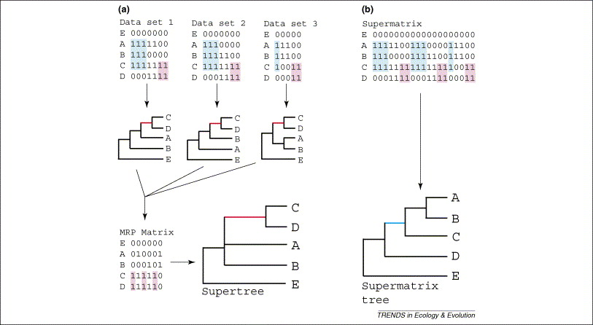

Figure 1: Image taken from Queiroz & Gatesy 2007 (2). (a) depicts the SuperTree method where each dataset, representing one locus, becomes its own tree. The single loci trees coalesce into the SuperTree. (b) shows the SuperMatrix method, where all loci are concatenated into a single dataset that becomes a single tree.

To test the congruency of the SuperTree and SuperMatrix methods, the dataset must be from an organism where the gene evolutionary history matches the species' evolutionary history. Mitochondrial genomes (mtDNA) are often thought to be inherited as a single unit since whole functional mitochondria are crucial in reproductive cells. Most animal lineages have linear mtDNA instead of chromosomes, which also contributes to the assumption of single-unit inheritance (3). Working under this assumption, the phylogenies produced from each method should produce identical trees.

**Methods**

Data Collection

The data was taken from a survey paper of Octocoral (mtDNA) and provided 90 new Octocoral mtDNA (4. All data used in the paper is available on Open Science Framework (5) The sequence data was partitioned by the mtDNA protein-coding sequences, of which there are 14: APT6, ATP8, COB, mutS, COX1, COX2, COX3, NAD1, NAD2, NAD3, NAD4L, NAD4, NAD5, NAD6. The dataset included 12 Hexacorals as the outgroup with a total of 184 species.

SuperTree Approach

Each gene file was aligned using MAFFT (6-7) with the “--auto” argument. Gene trees were made with RaxML-ng (8) using the model GTR+G and seed 951. The gene trees coalesced with ASTRAL 5.7.8 (9) to form the SuperTree.

SuperMaxtrix Approach

The gene files were concatenated into a single file using the shell command “cat”. A python3 script was created to sort the concatenated file by species, where all genes for a species were concatenated into a single line. The script can be found in the GitHub repository (<https://github.com/d-hayes/EEOB563-Final-Project>). The species SuperMatrix tree was created using the same steps as the SuperTree, aligned using MAFFT “--auto” and built with RaxML under the GTR+G model.

Phylogenetic Comparison

All trees were visualized using Figtree (10) and IcyTree (11). The phylogenies were compared manually using visual inspection. While not the most accurate, there were unexpected issues with comparison programs.

**Results**

SuperTree

The gene trees were all quite similar. The branch lengths varied marginally across trees, likely due to the varying quantity of conserved regions, as all genes used are critical for mitochondrial function. There are some notable differences between which trees have long branches and the length of those branches. The long branches may be due to non-synonamous mutations. However, these alone do not seem likely to account for the complete length, particularly the longest branch.

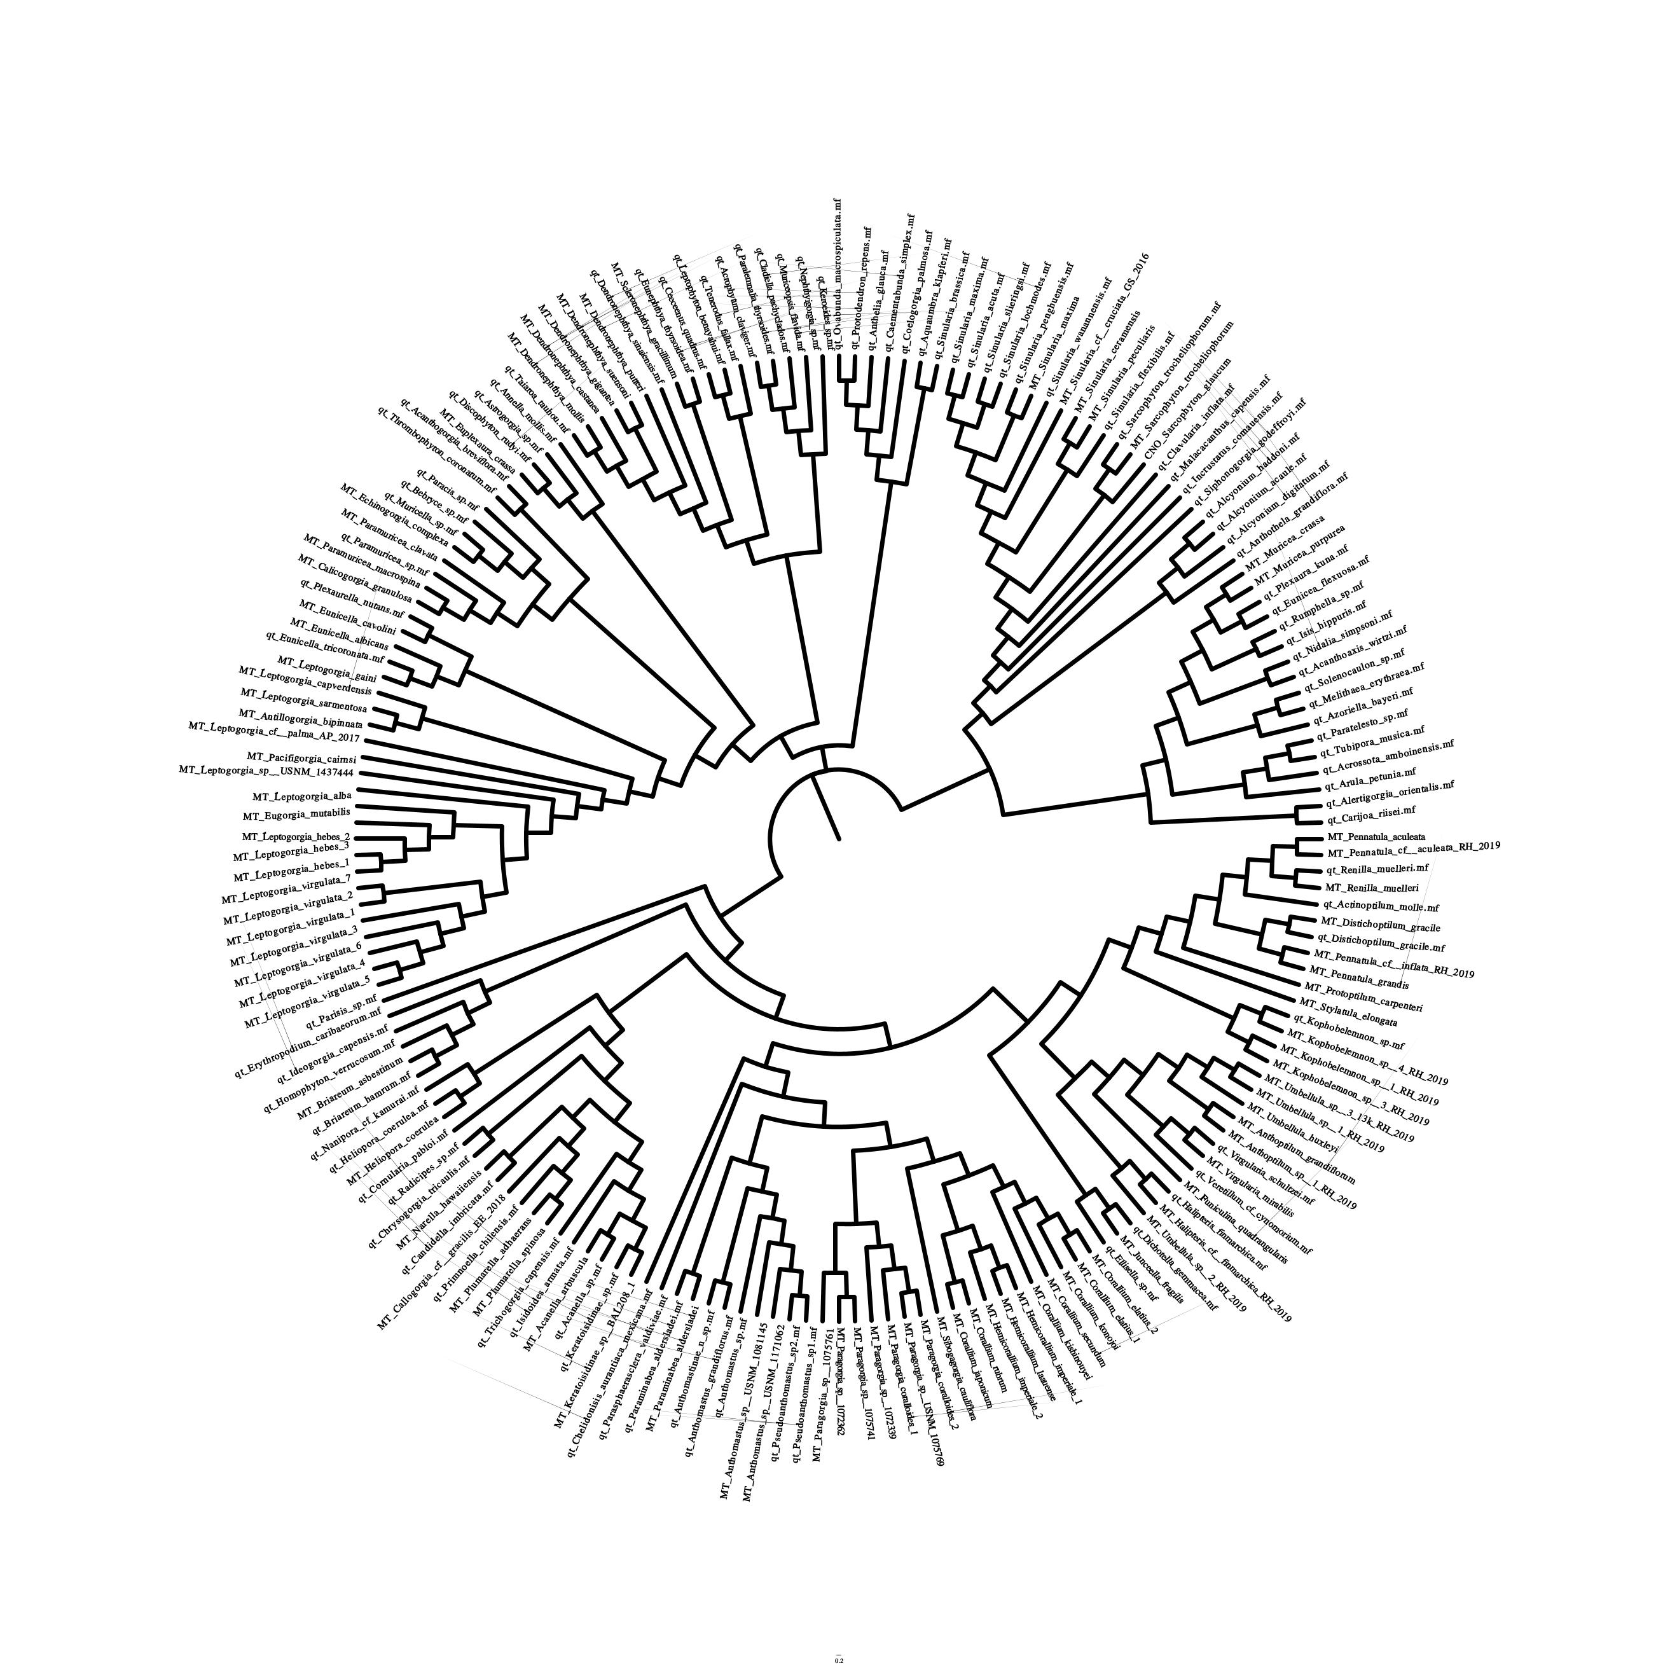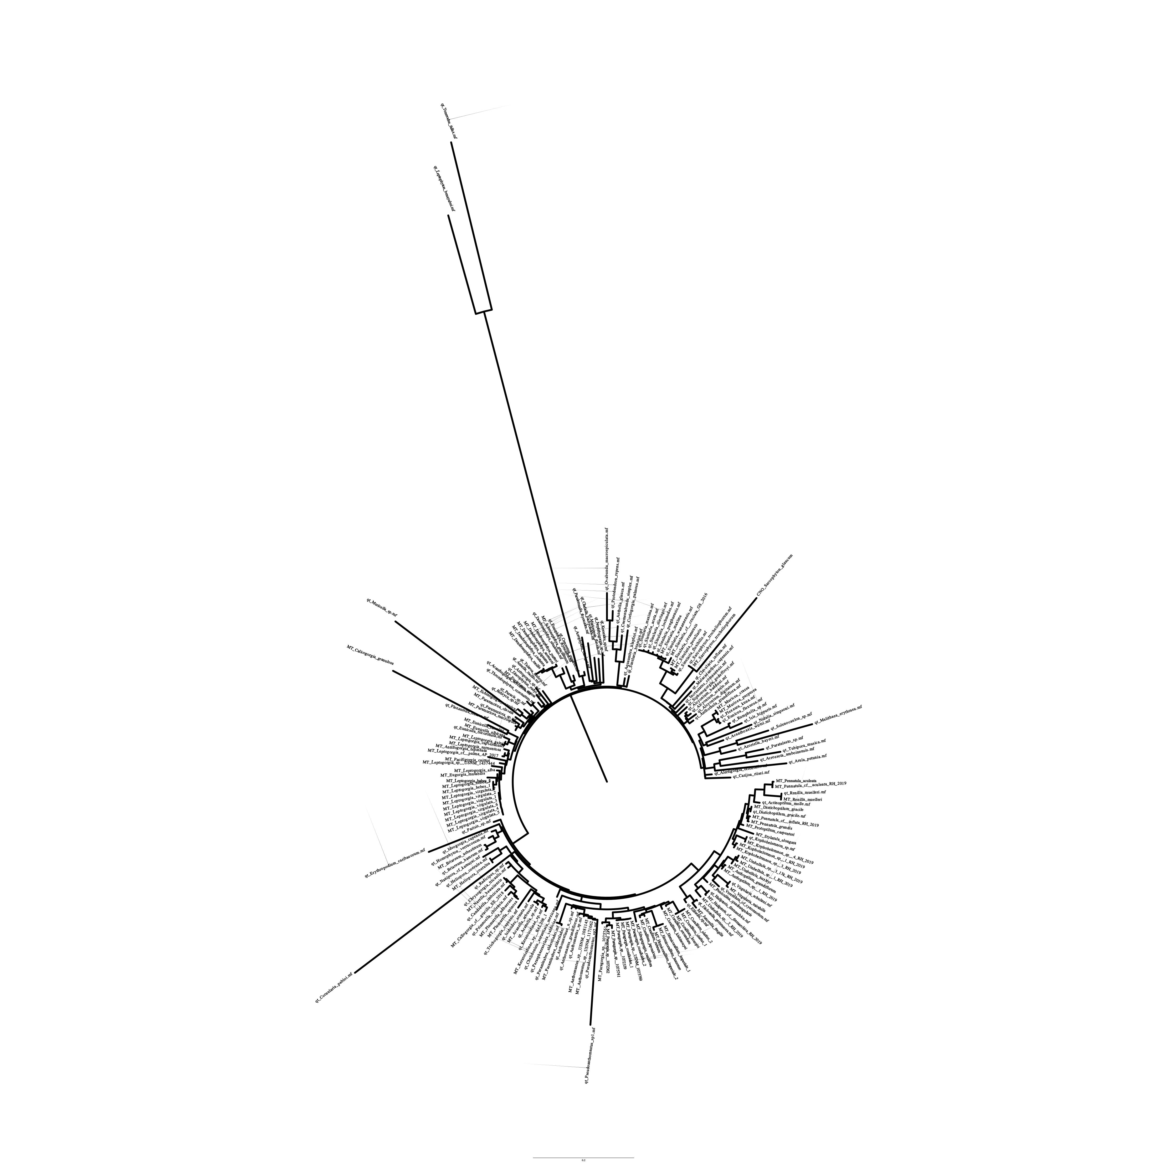

Figure 2: ATP6 gene tree with transformed branch lengths (left) and distance-based branch lengths (right).

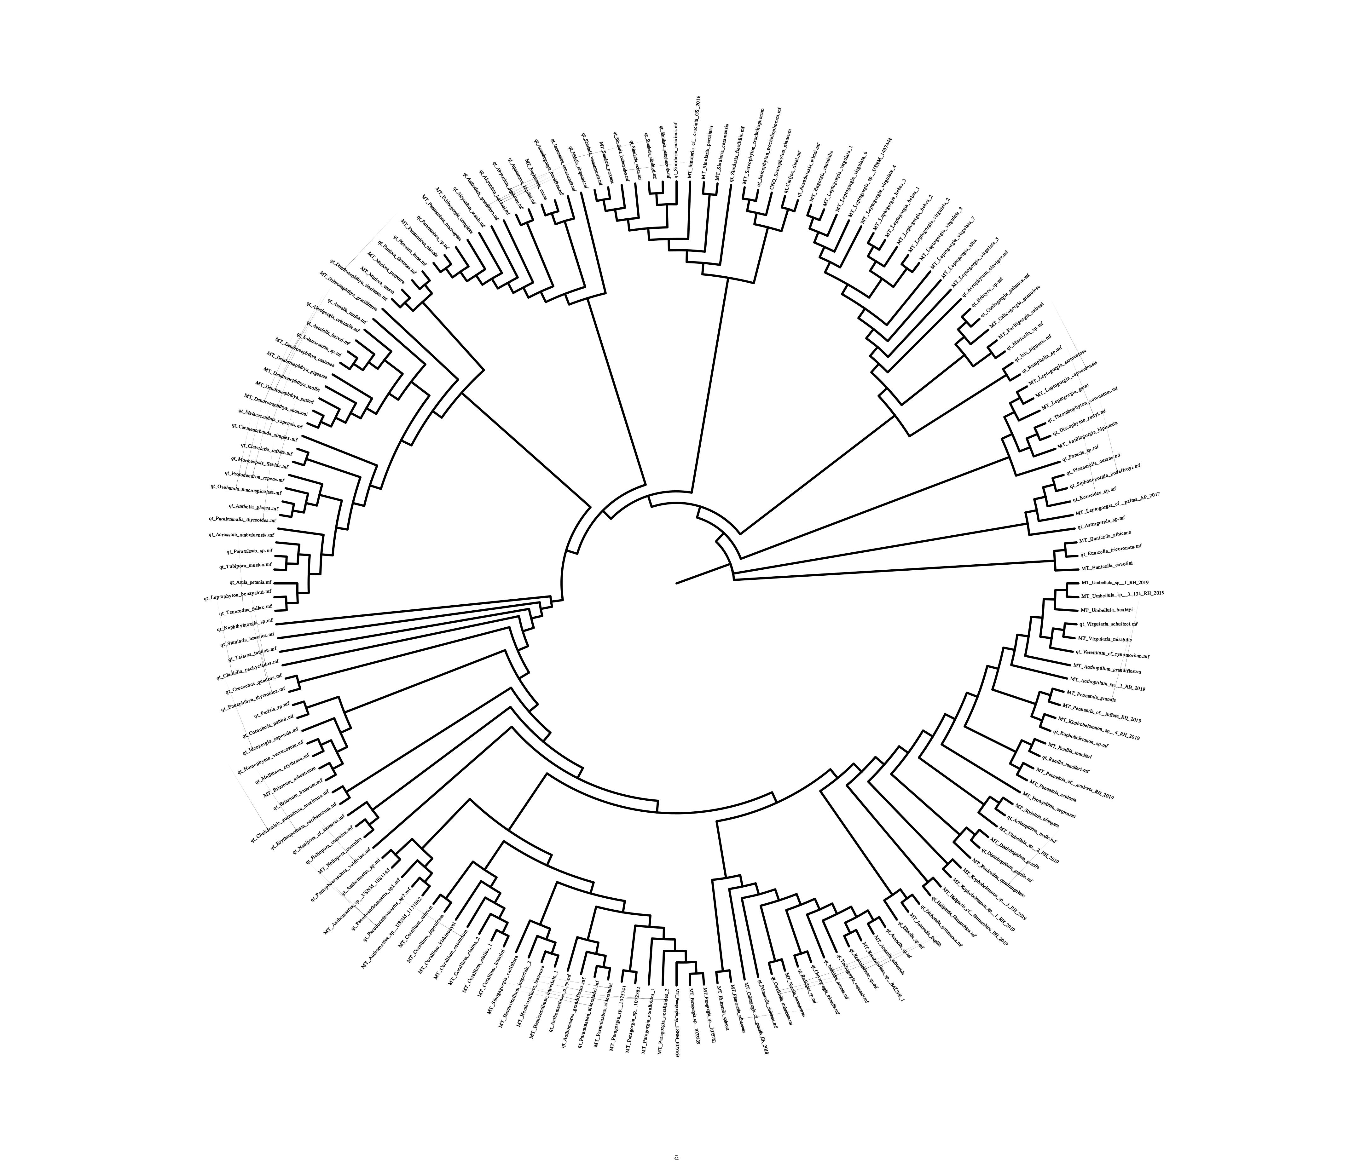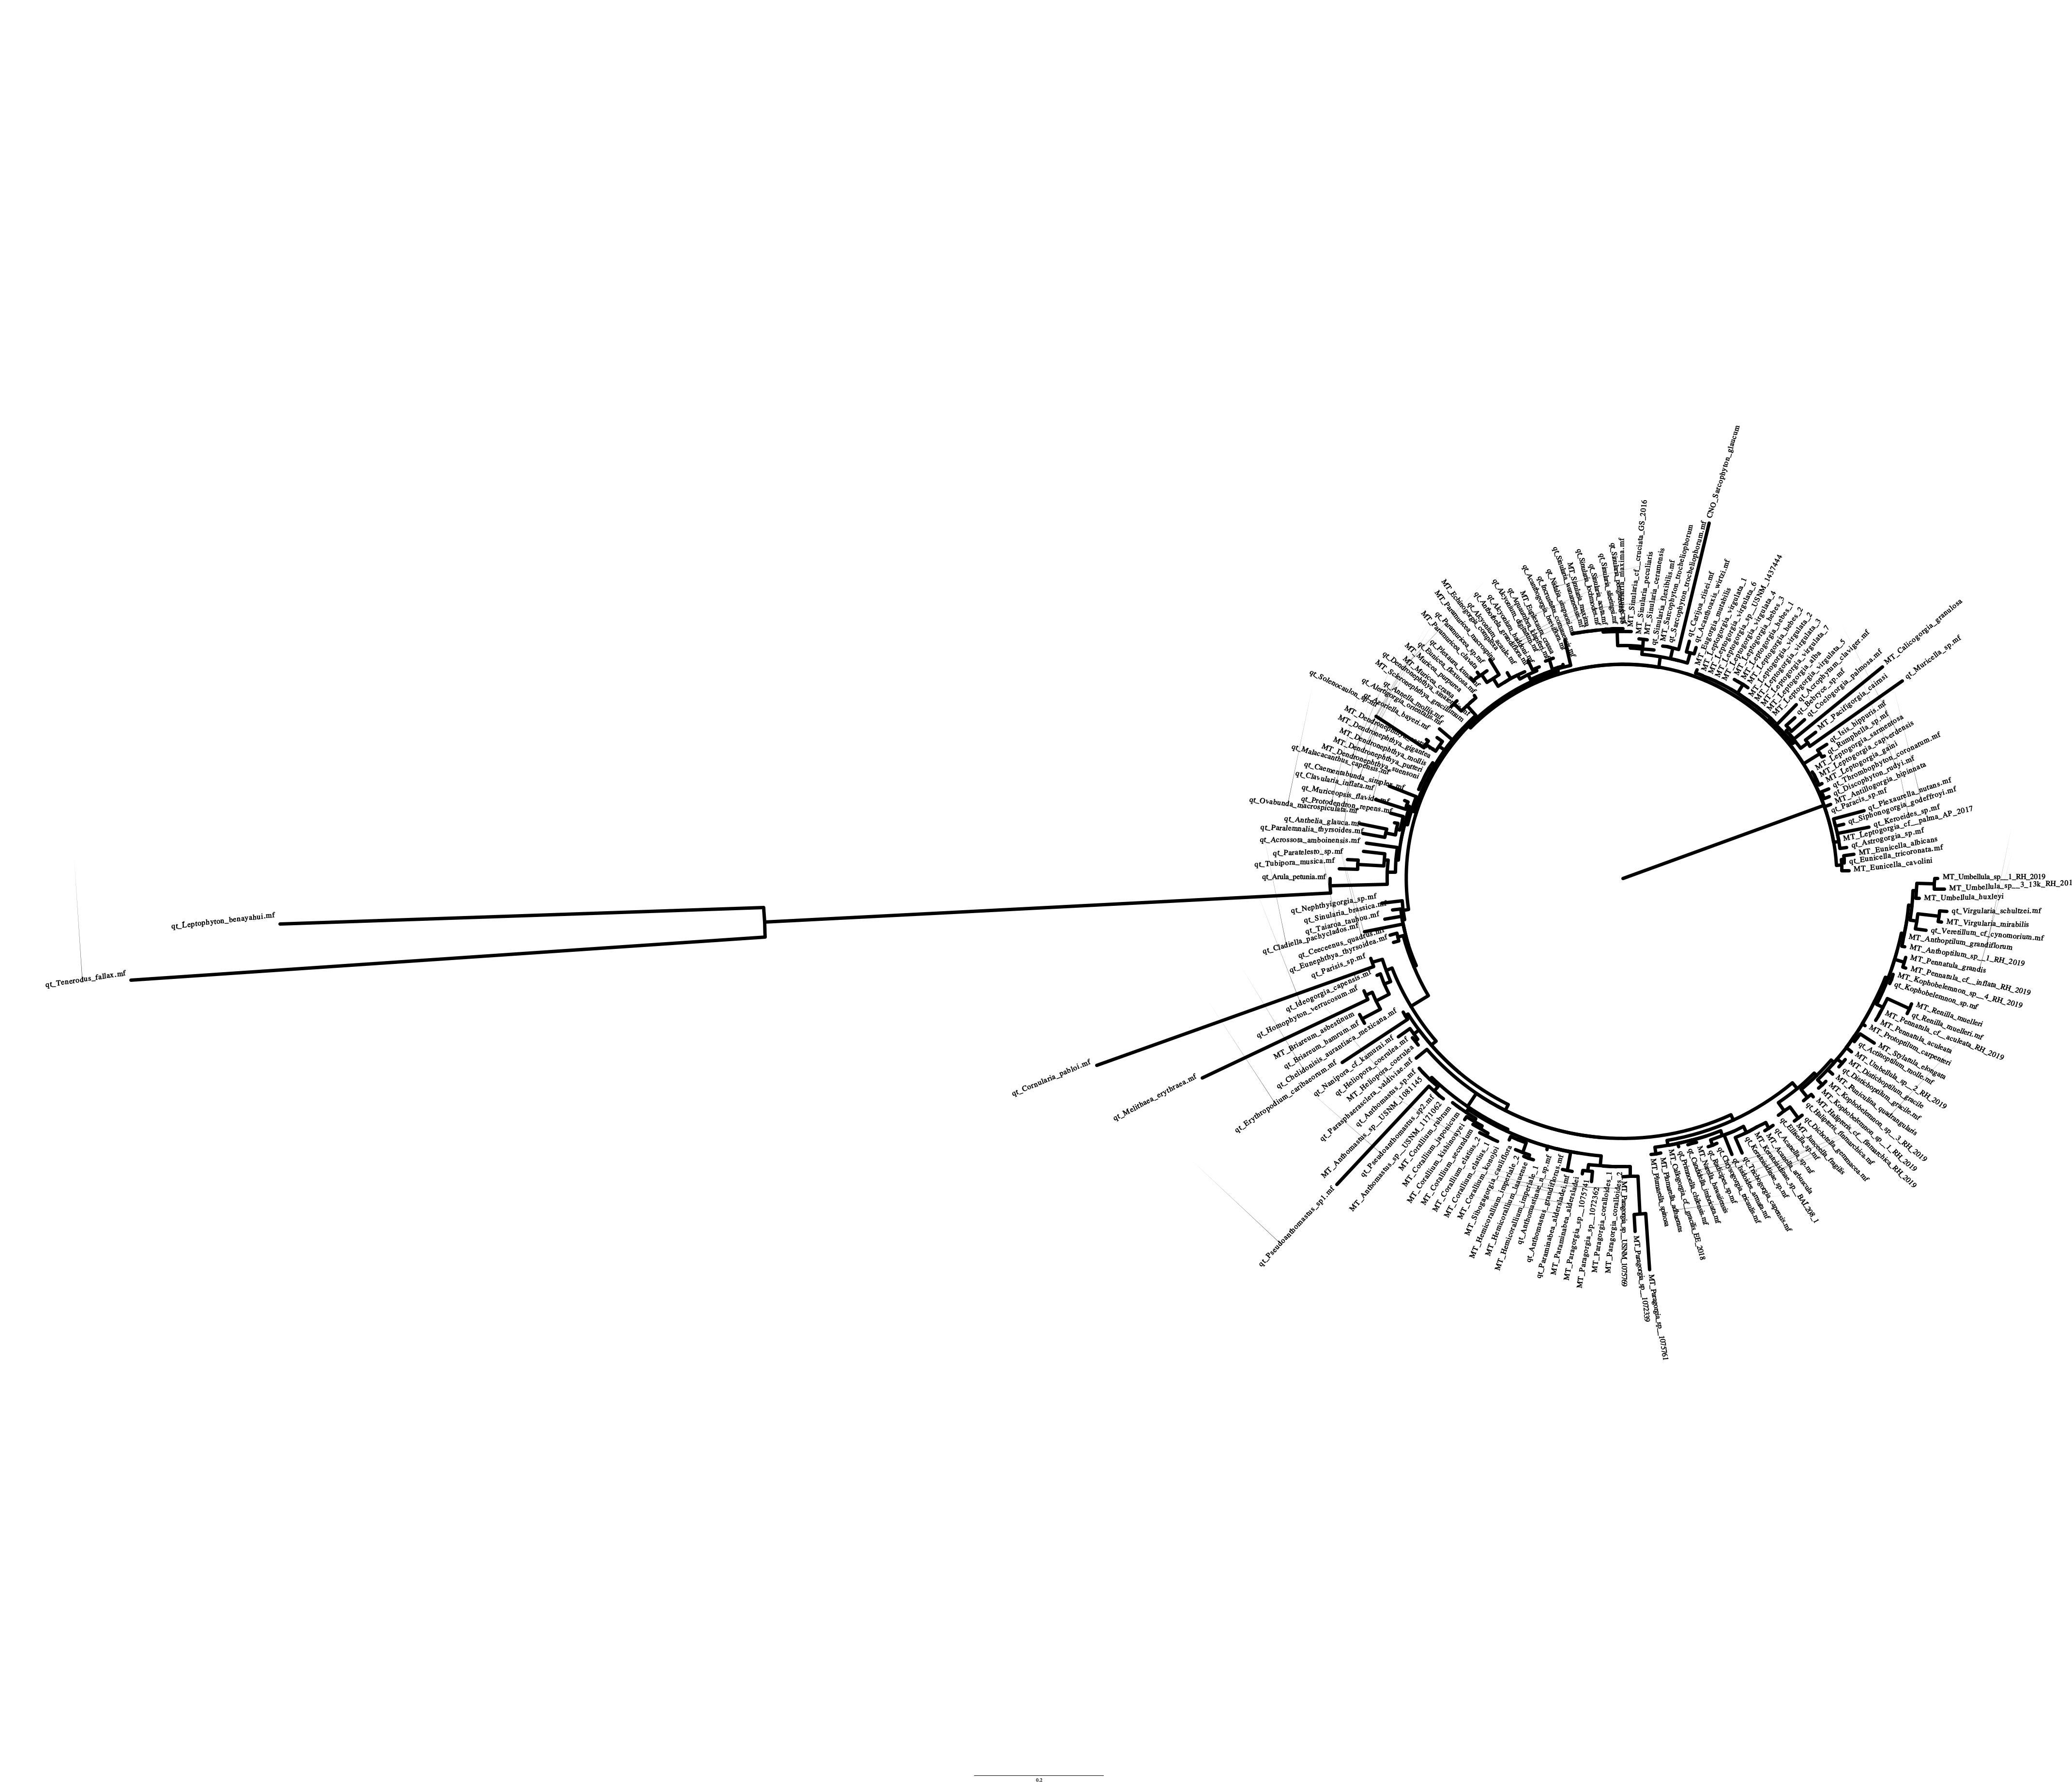 Figure 3: ATP8 gene tree with transformed branch lengths (left) and distance-based branch lengths (right).

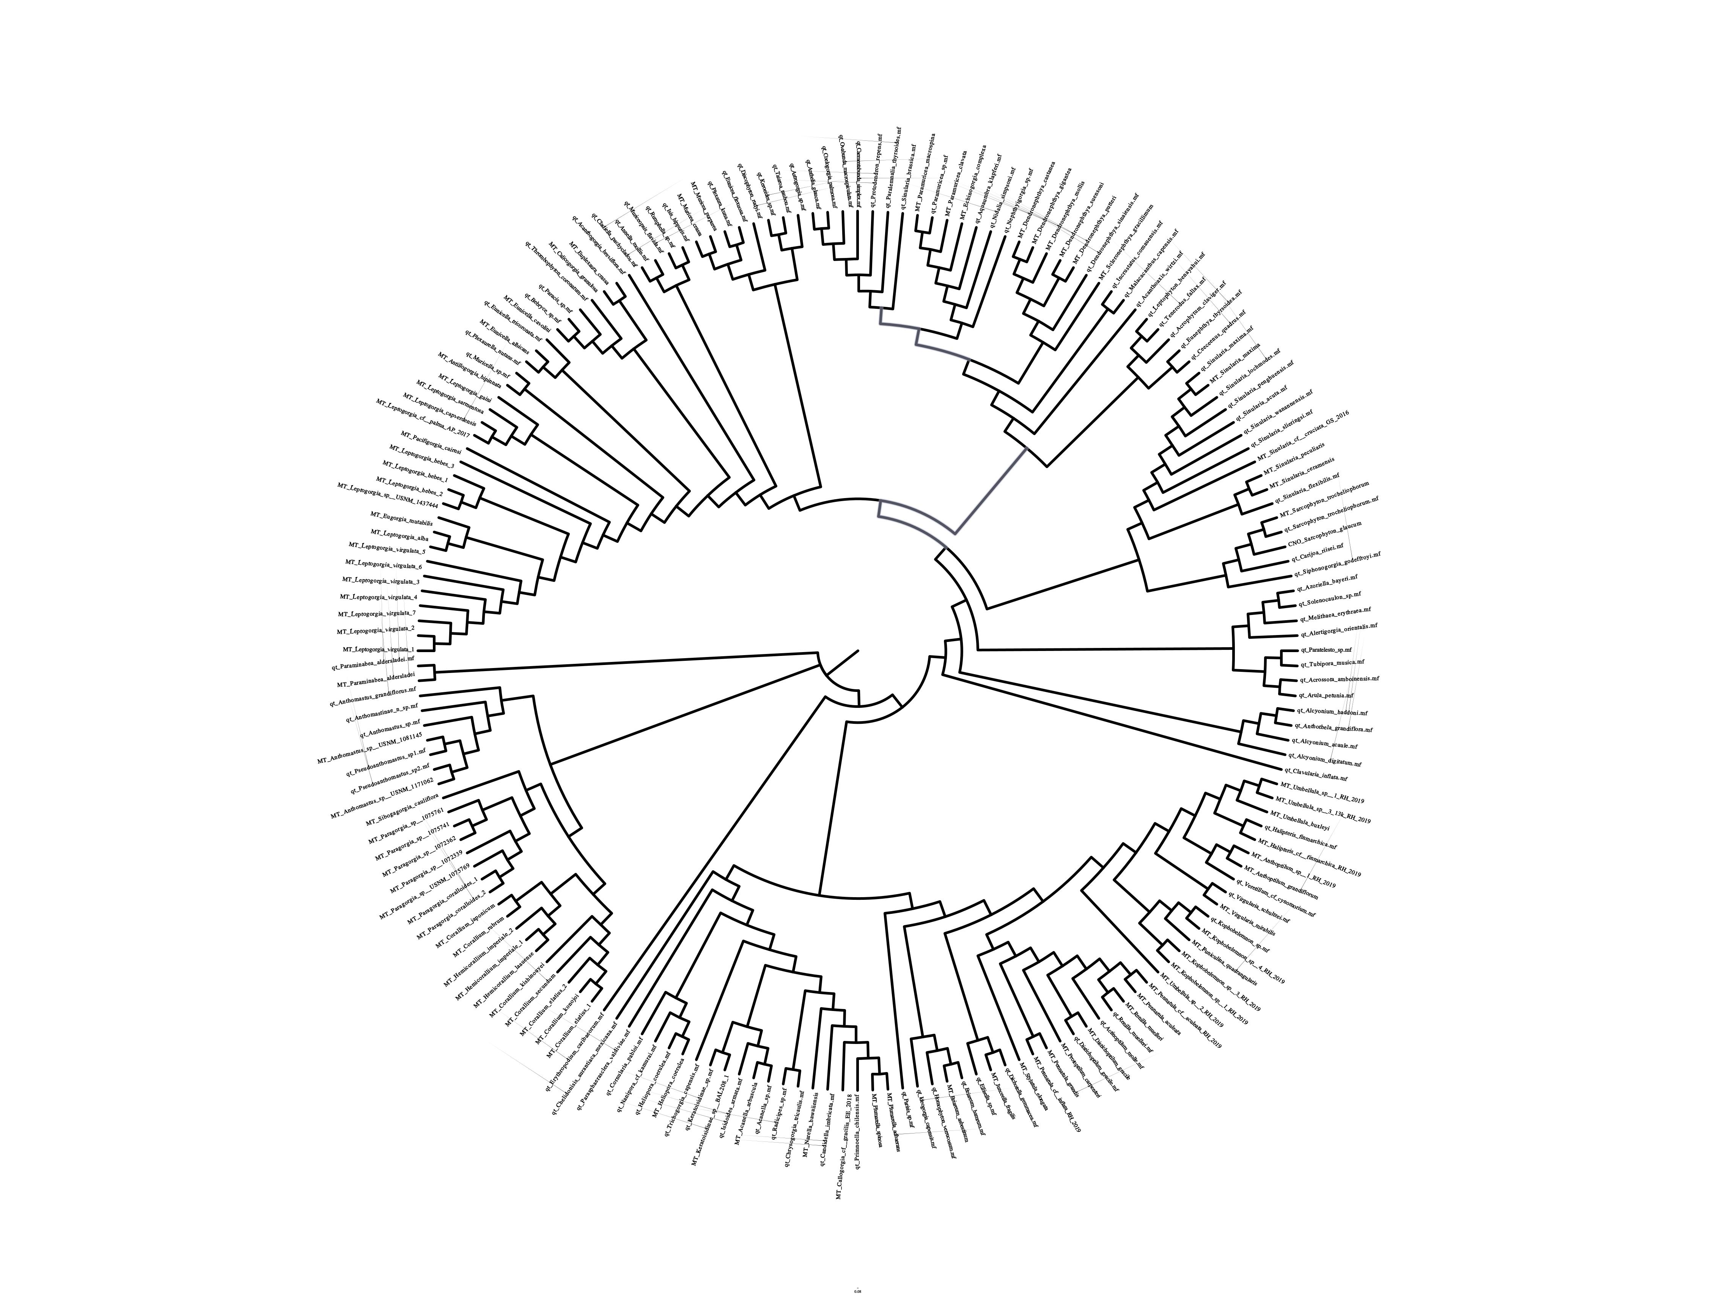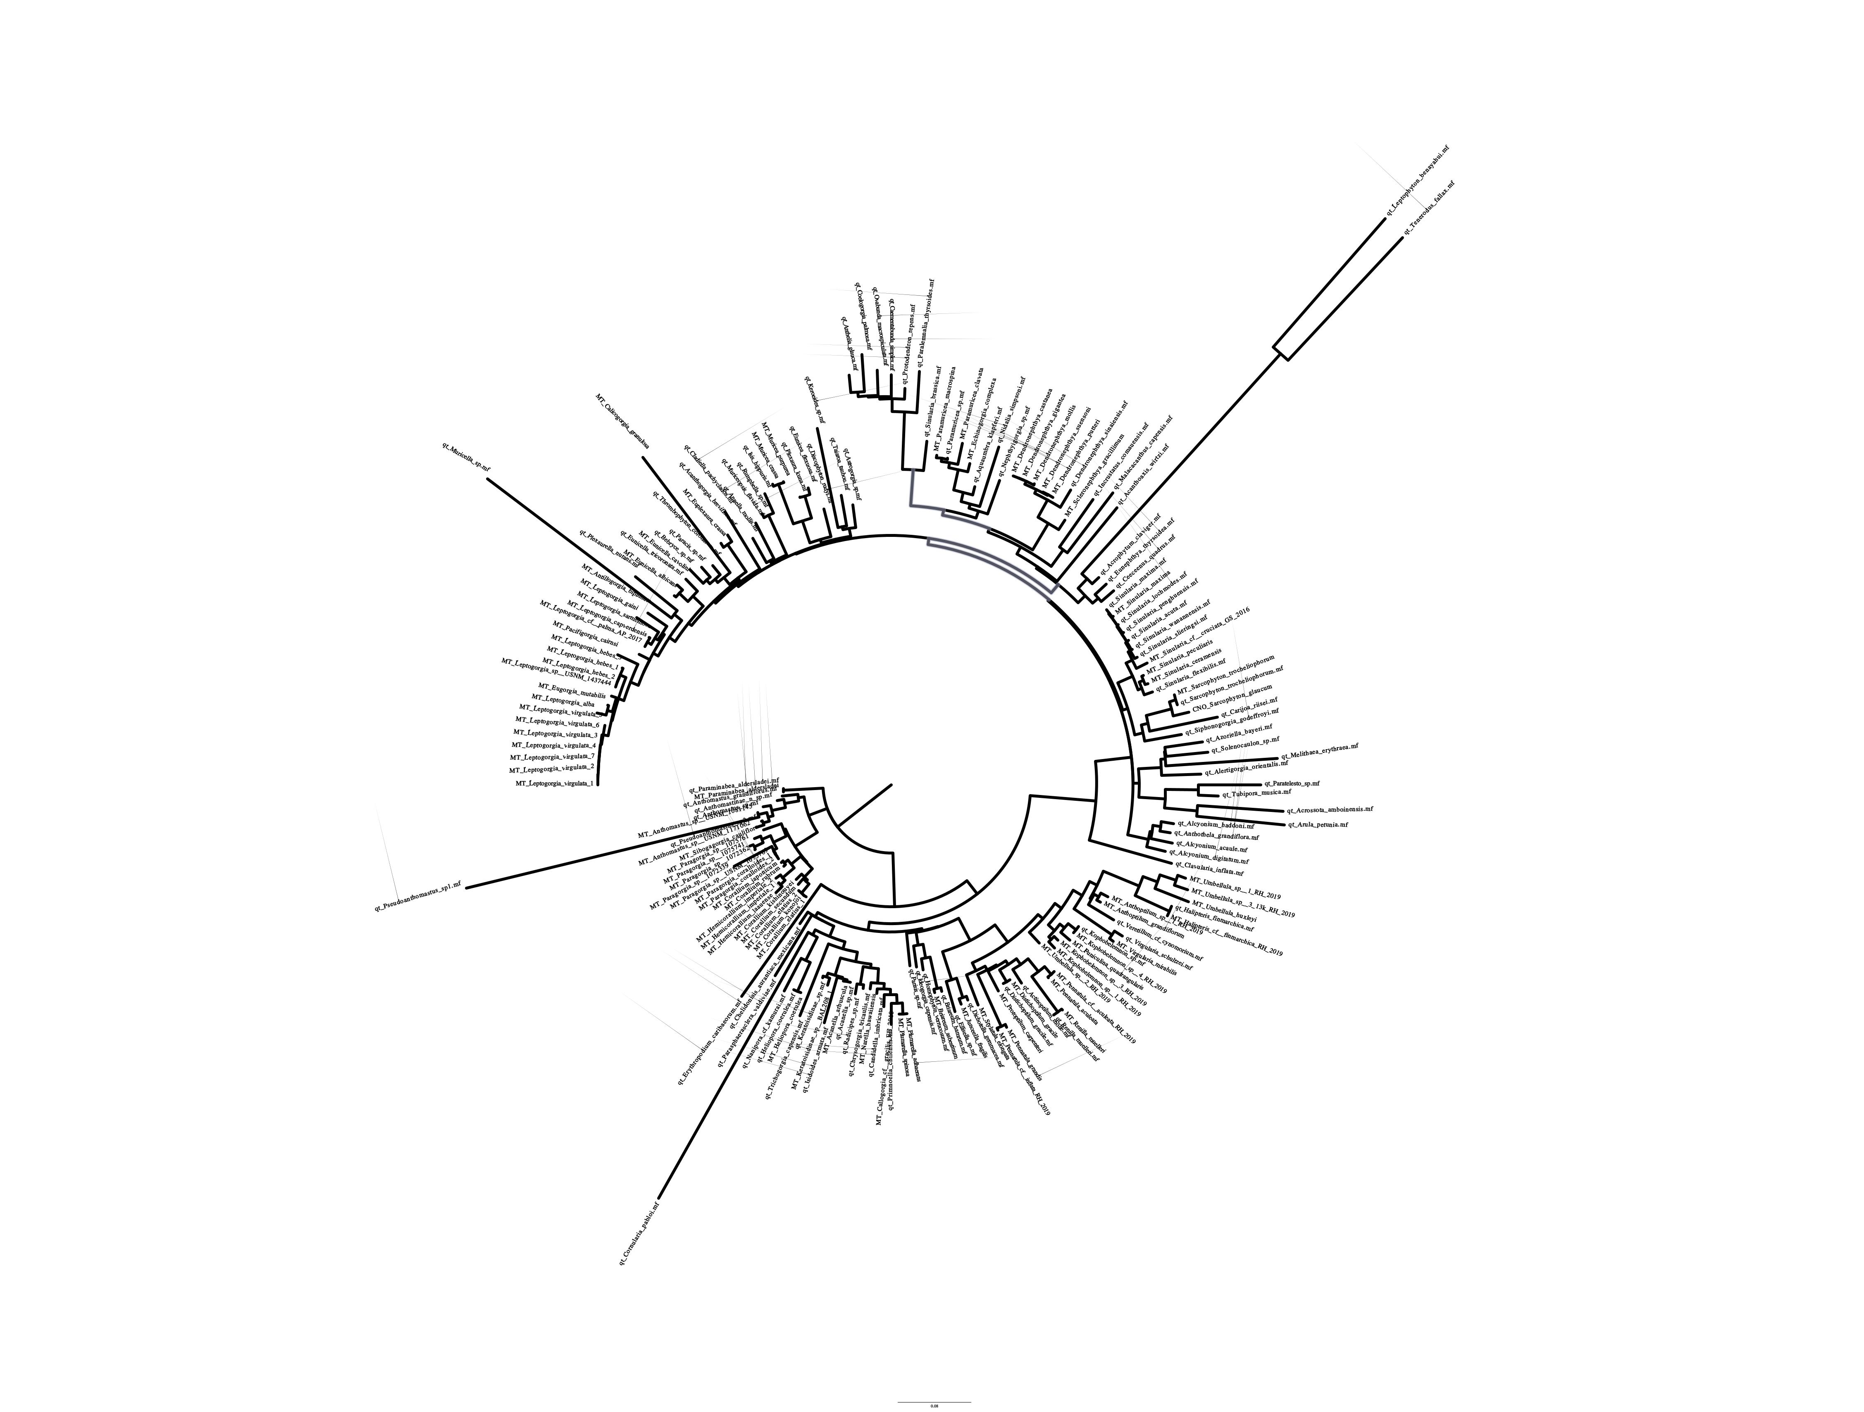

Figure 4: COB gene tree with transformed branch lengths (left) and distance-based branch lengths (right).

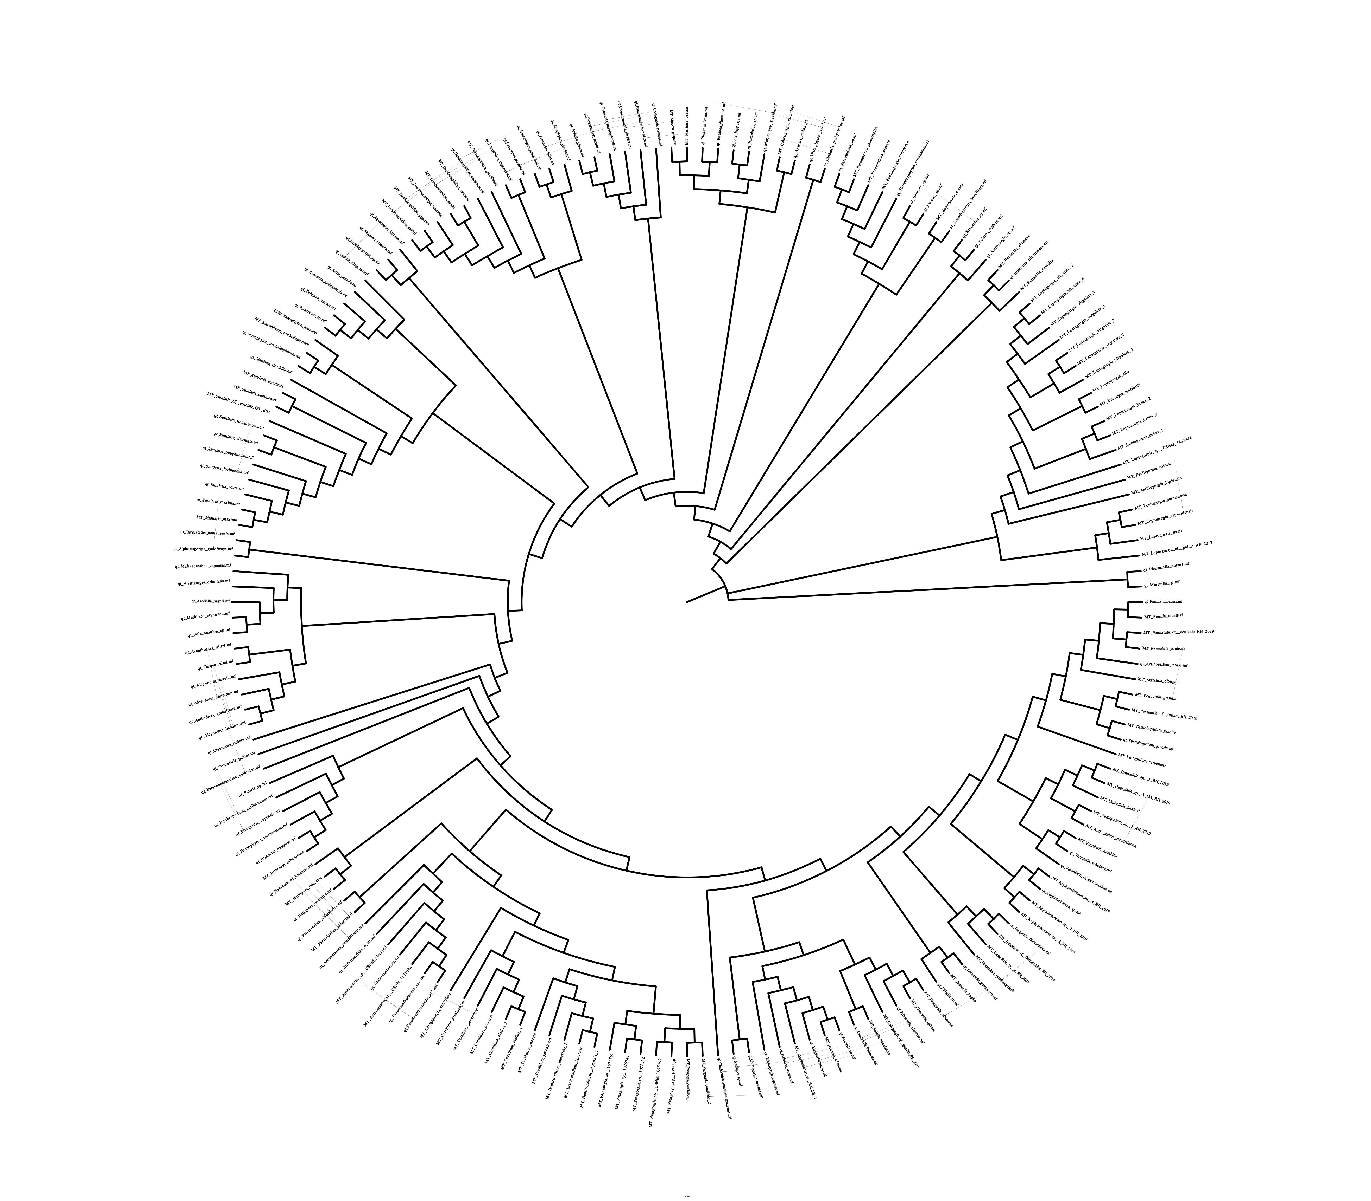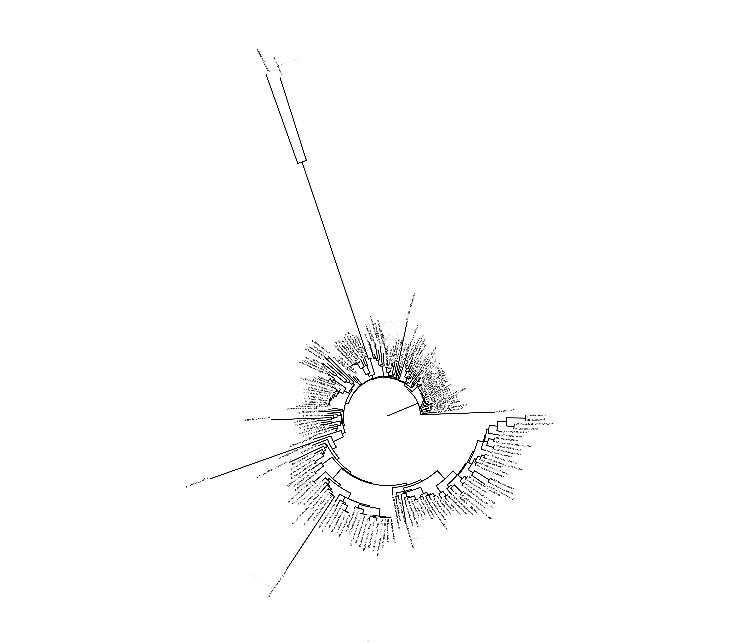

Figure 5: COX1 gene tree with transformed branch lengths (left) and distance-based branch lengths (right).

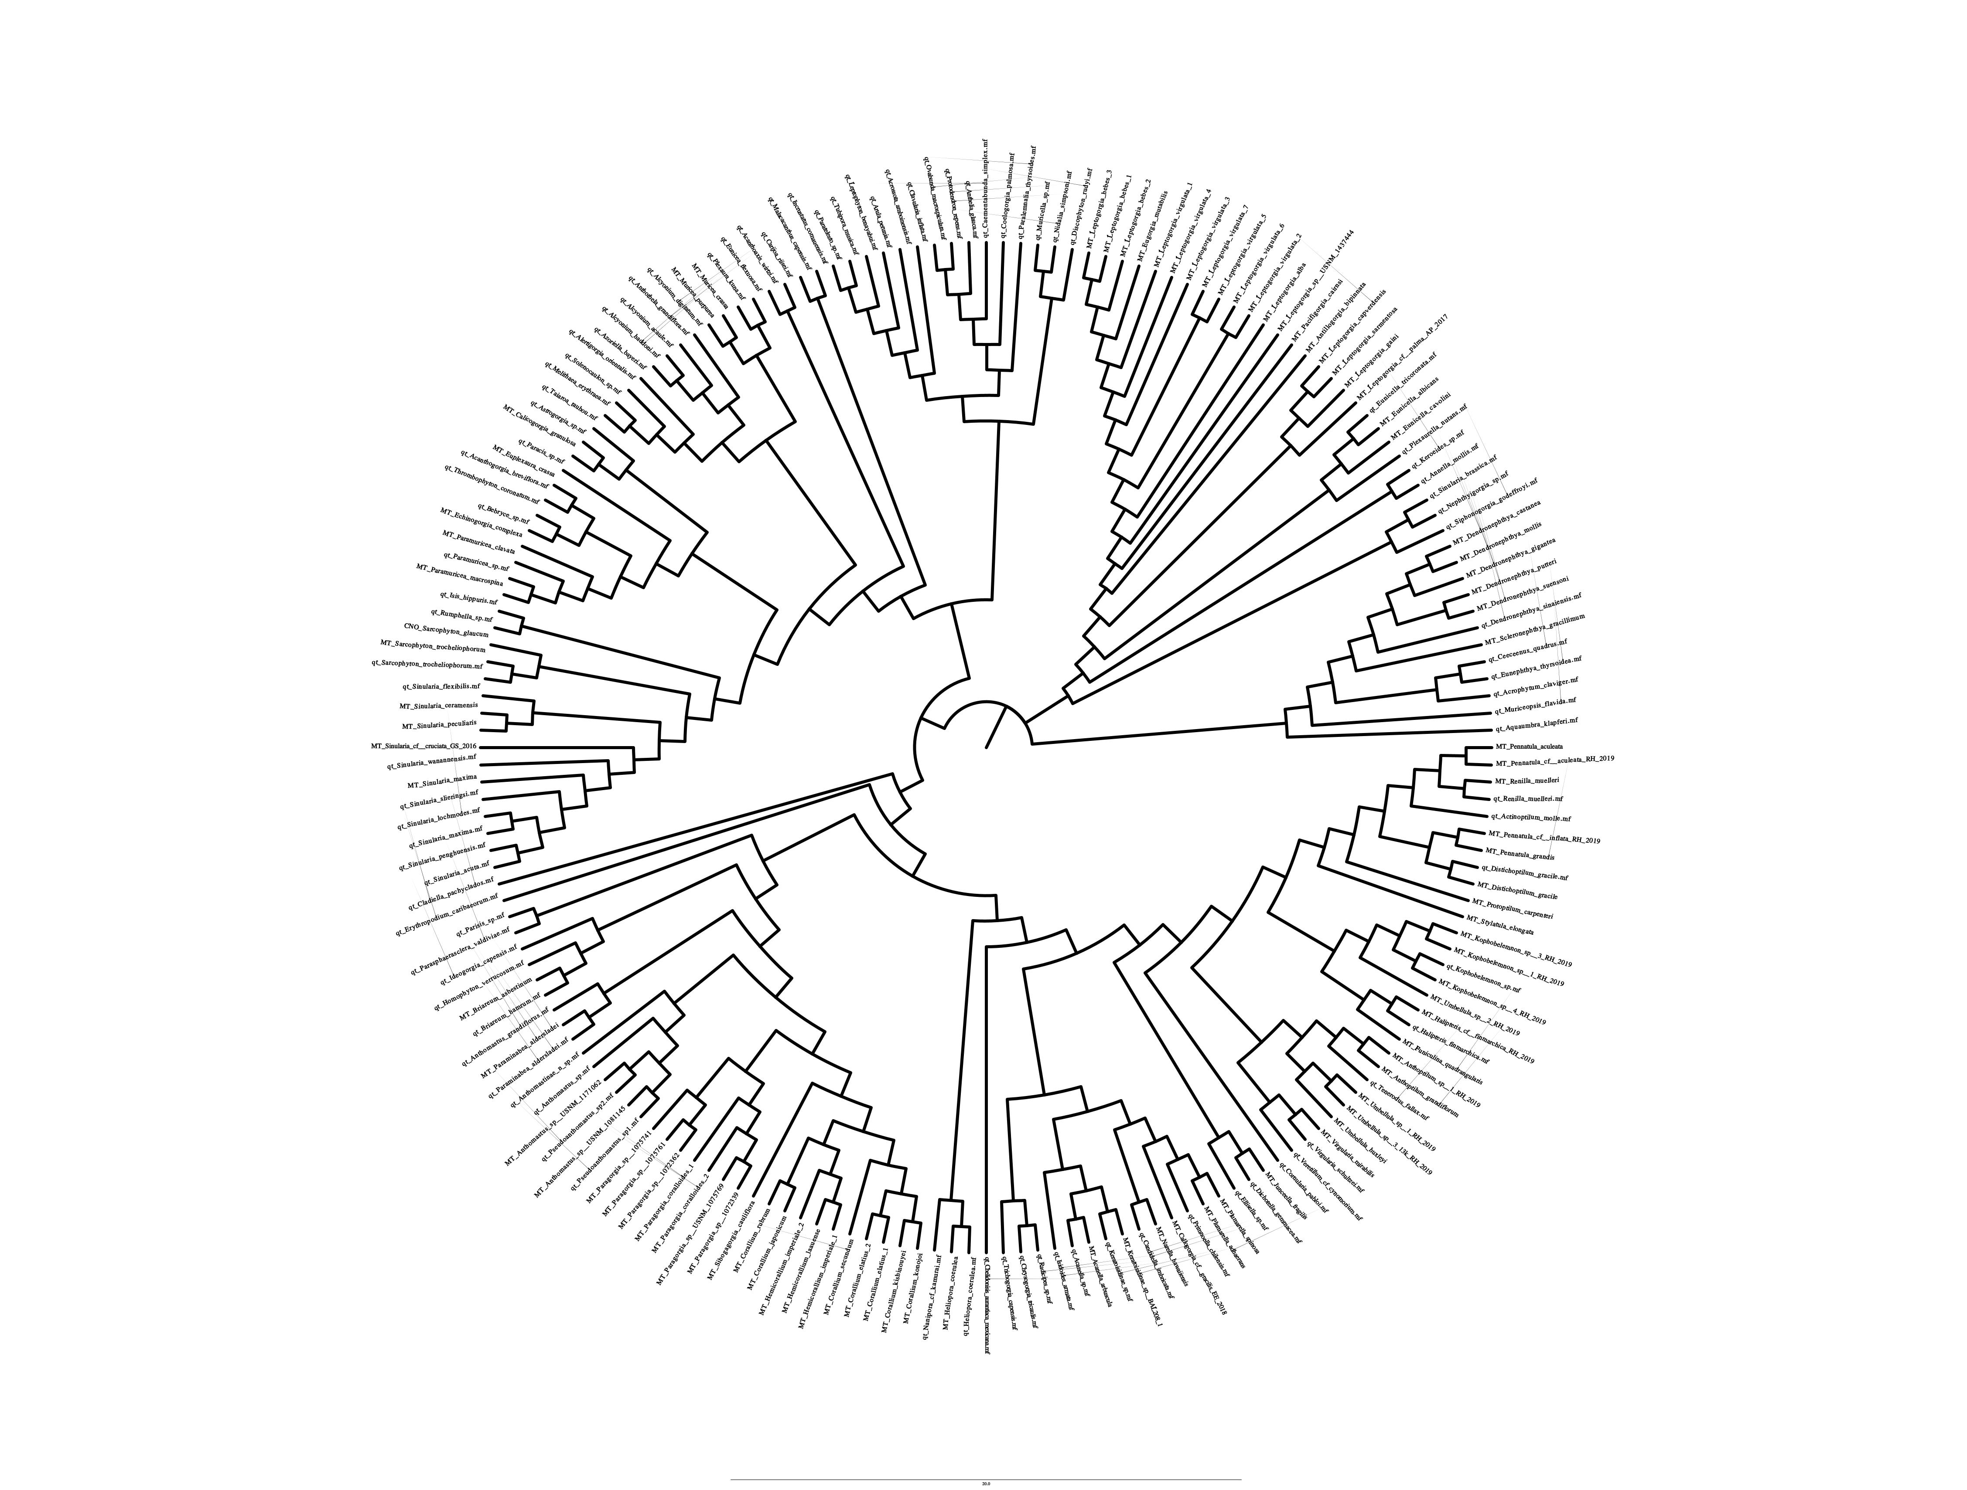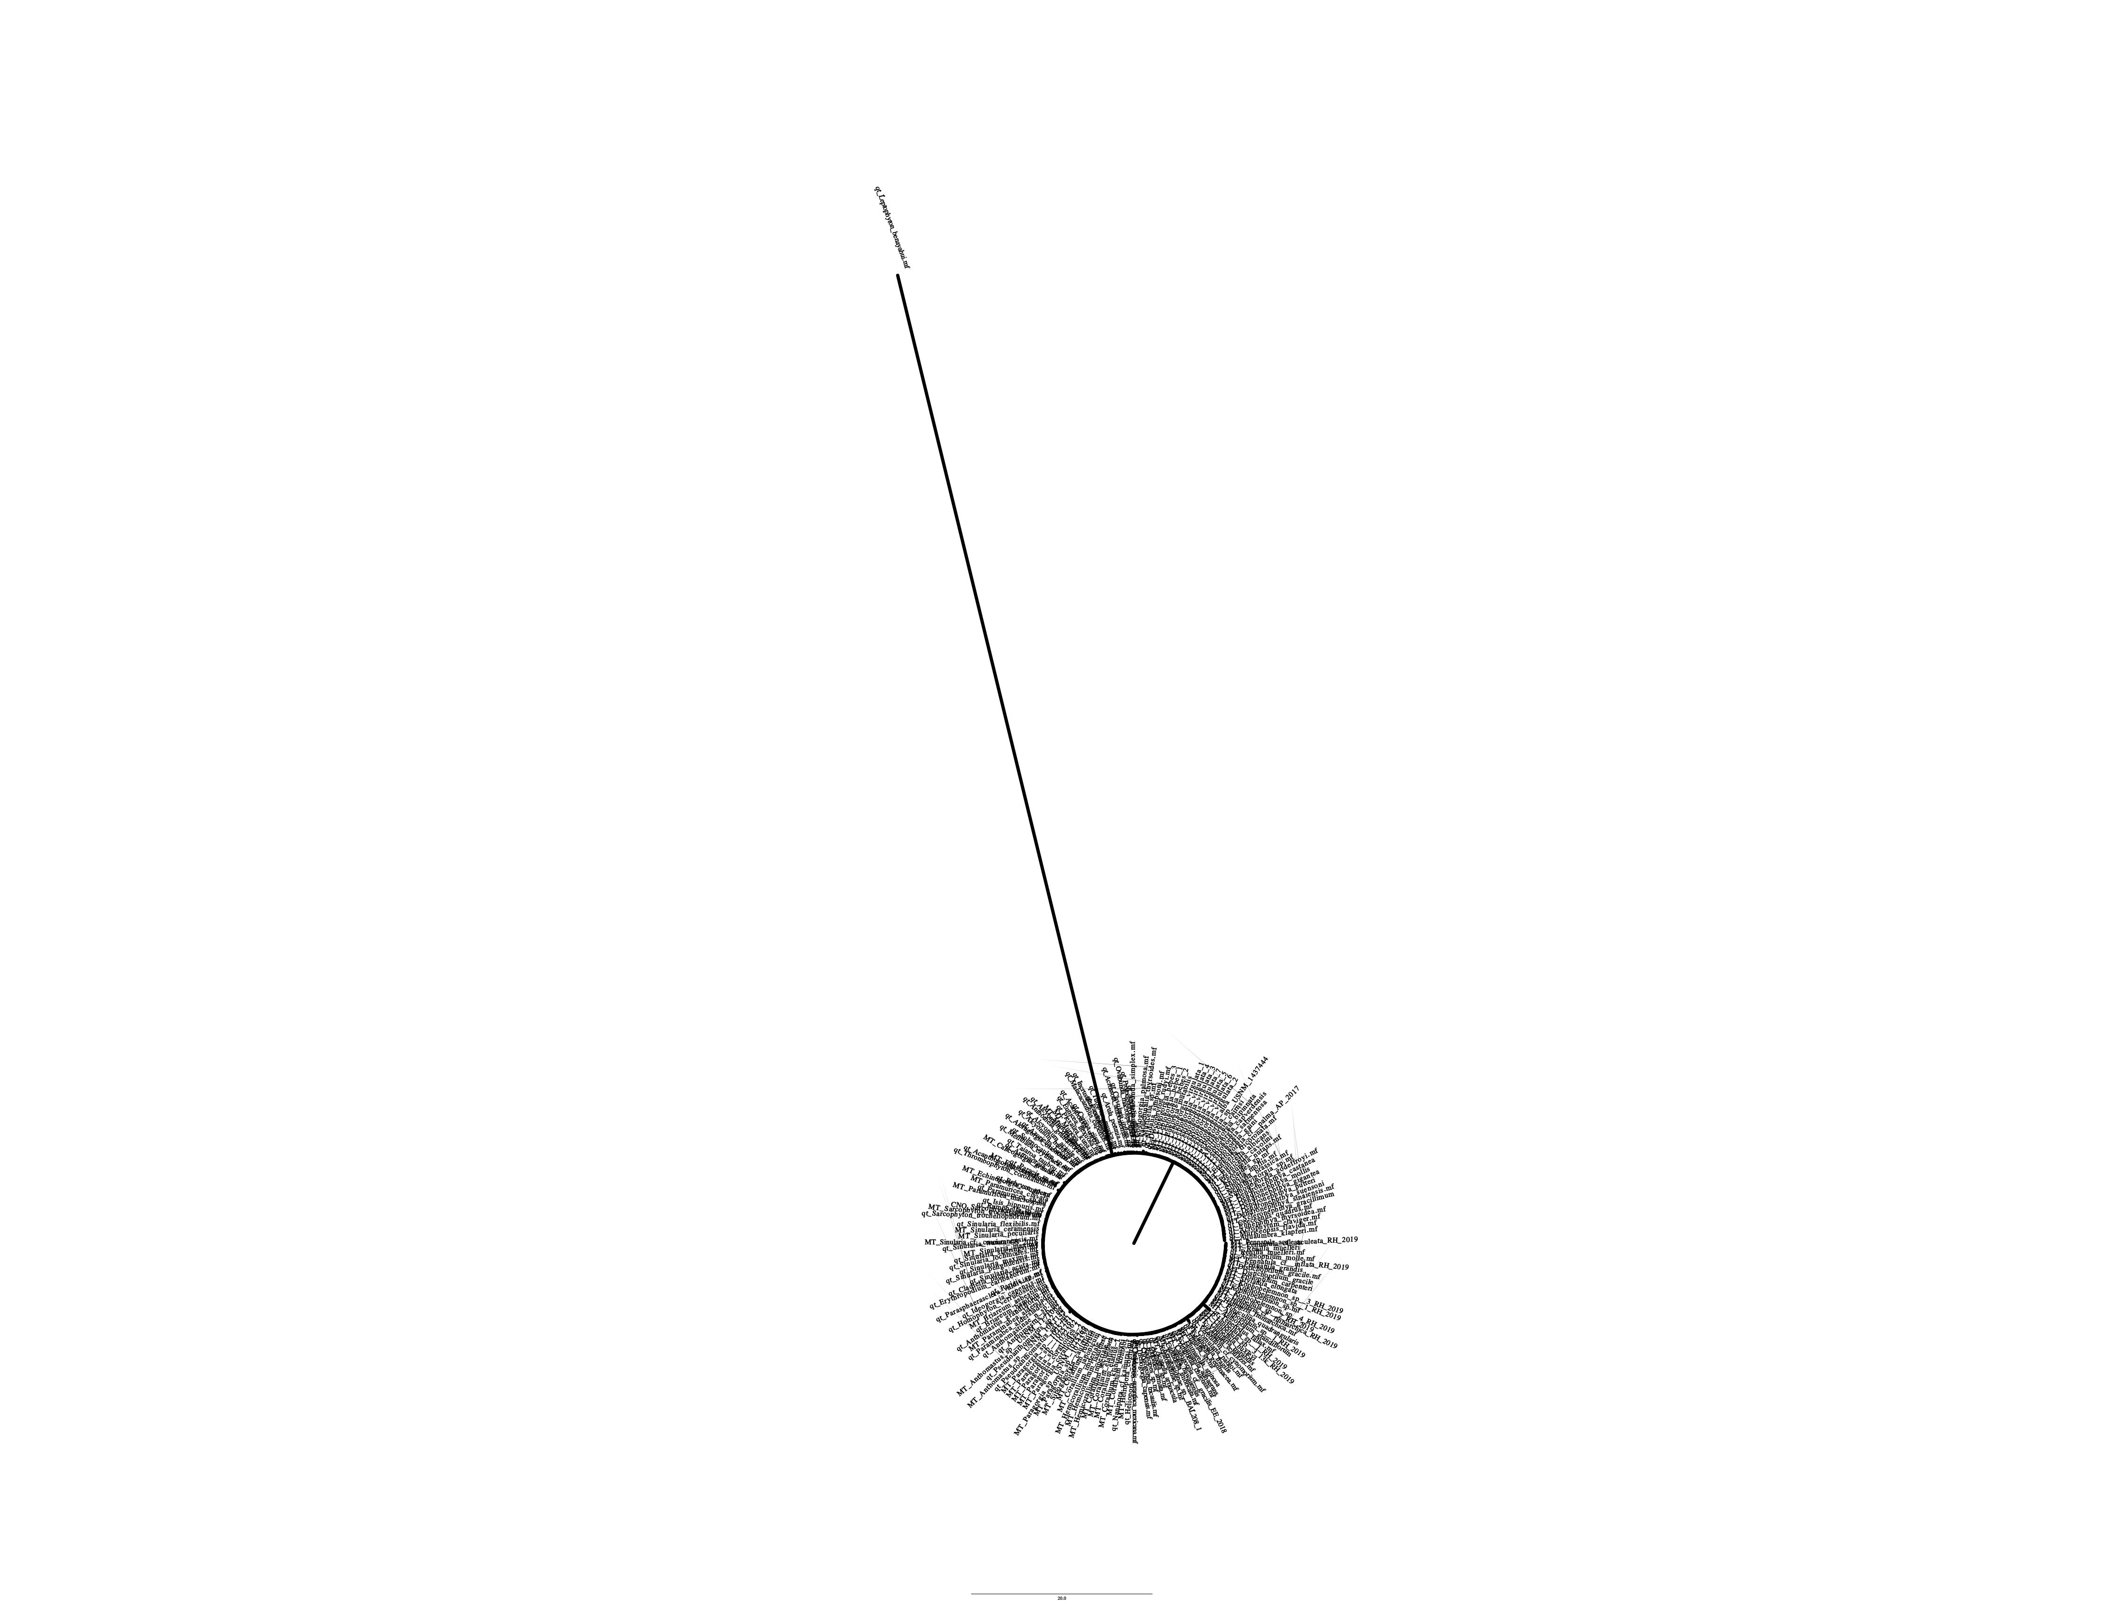

Figure 6: COX2 gene tree with transformed branch lengths (left) and distance-based branch lengths (right).

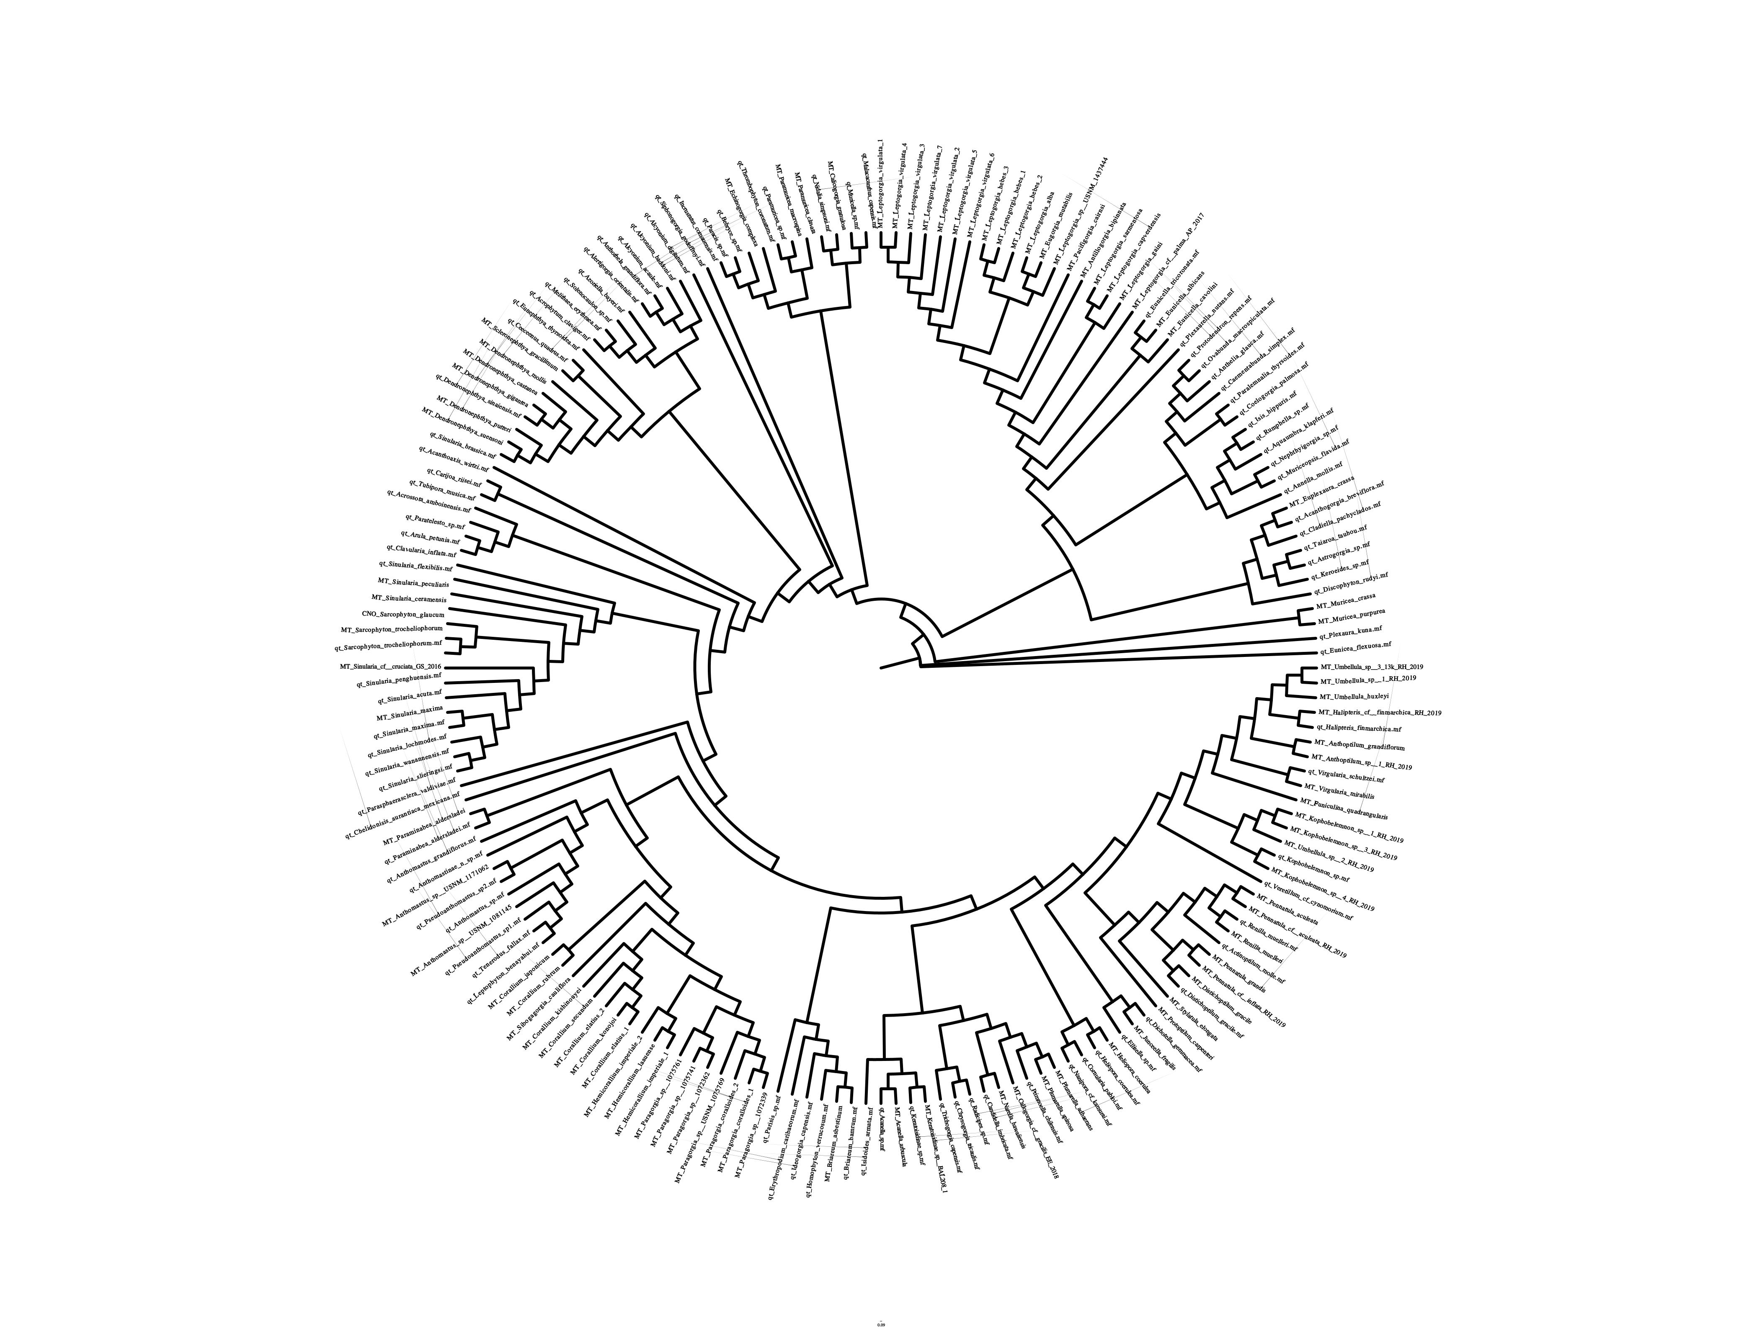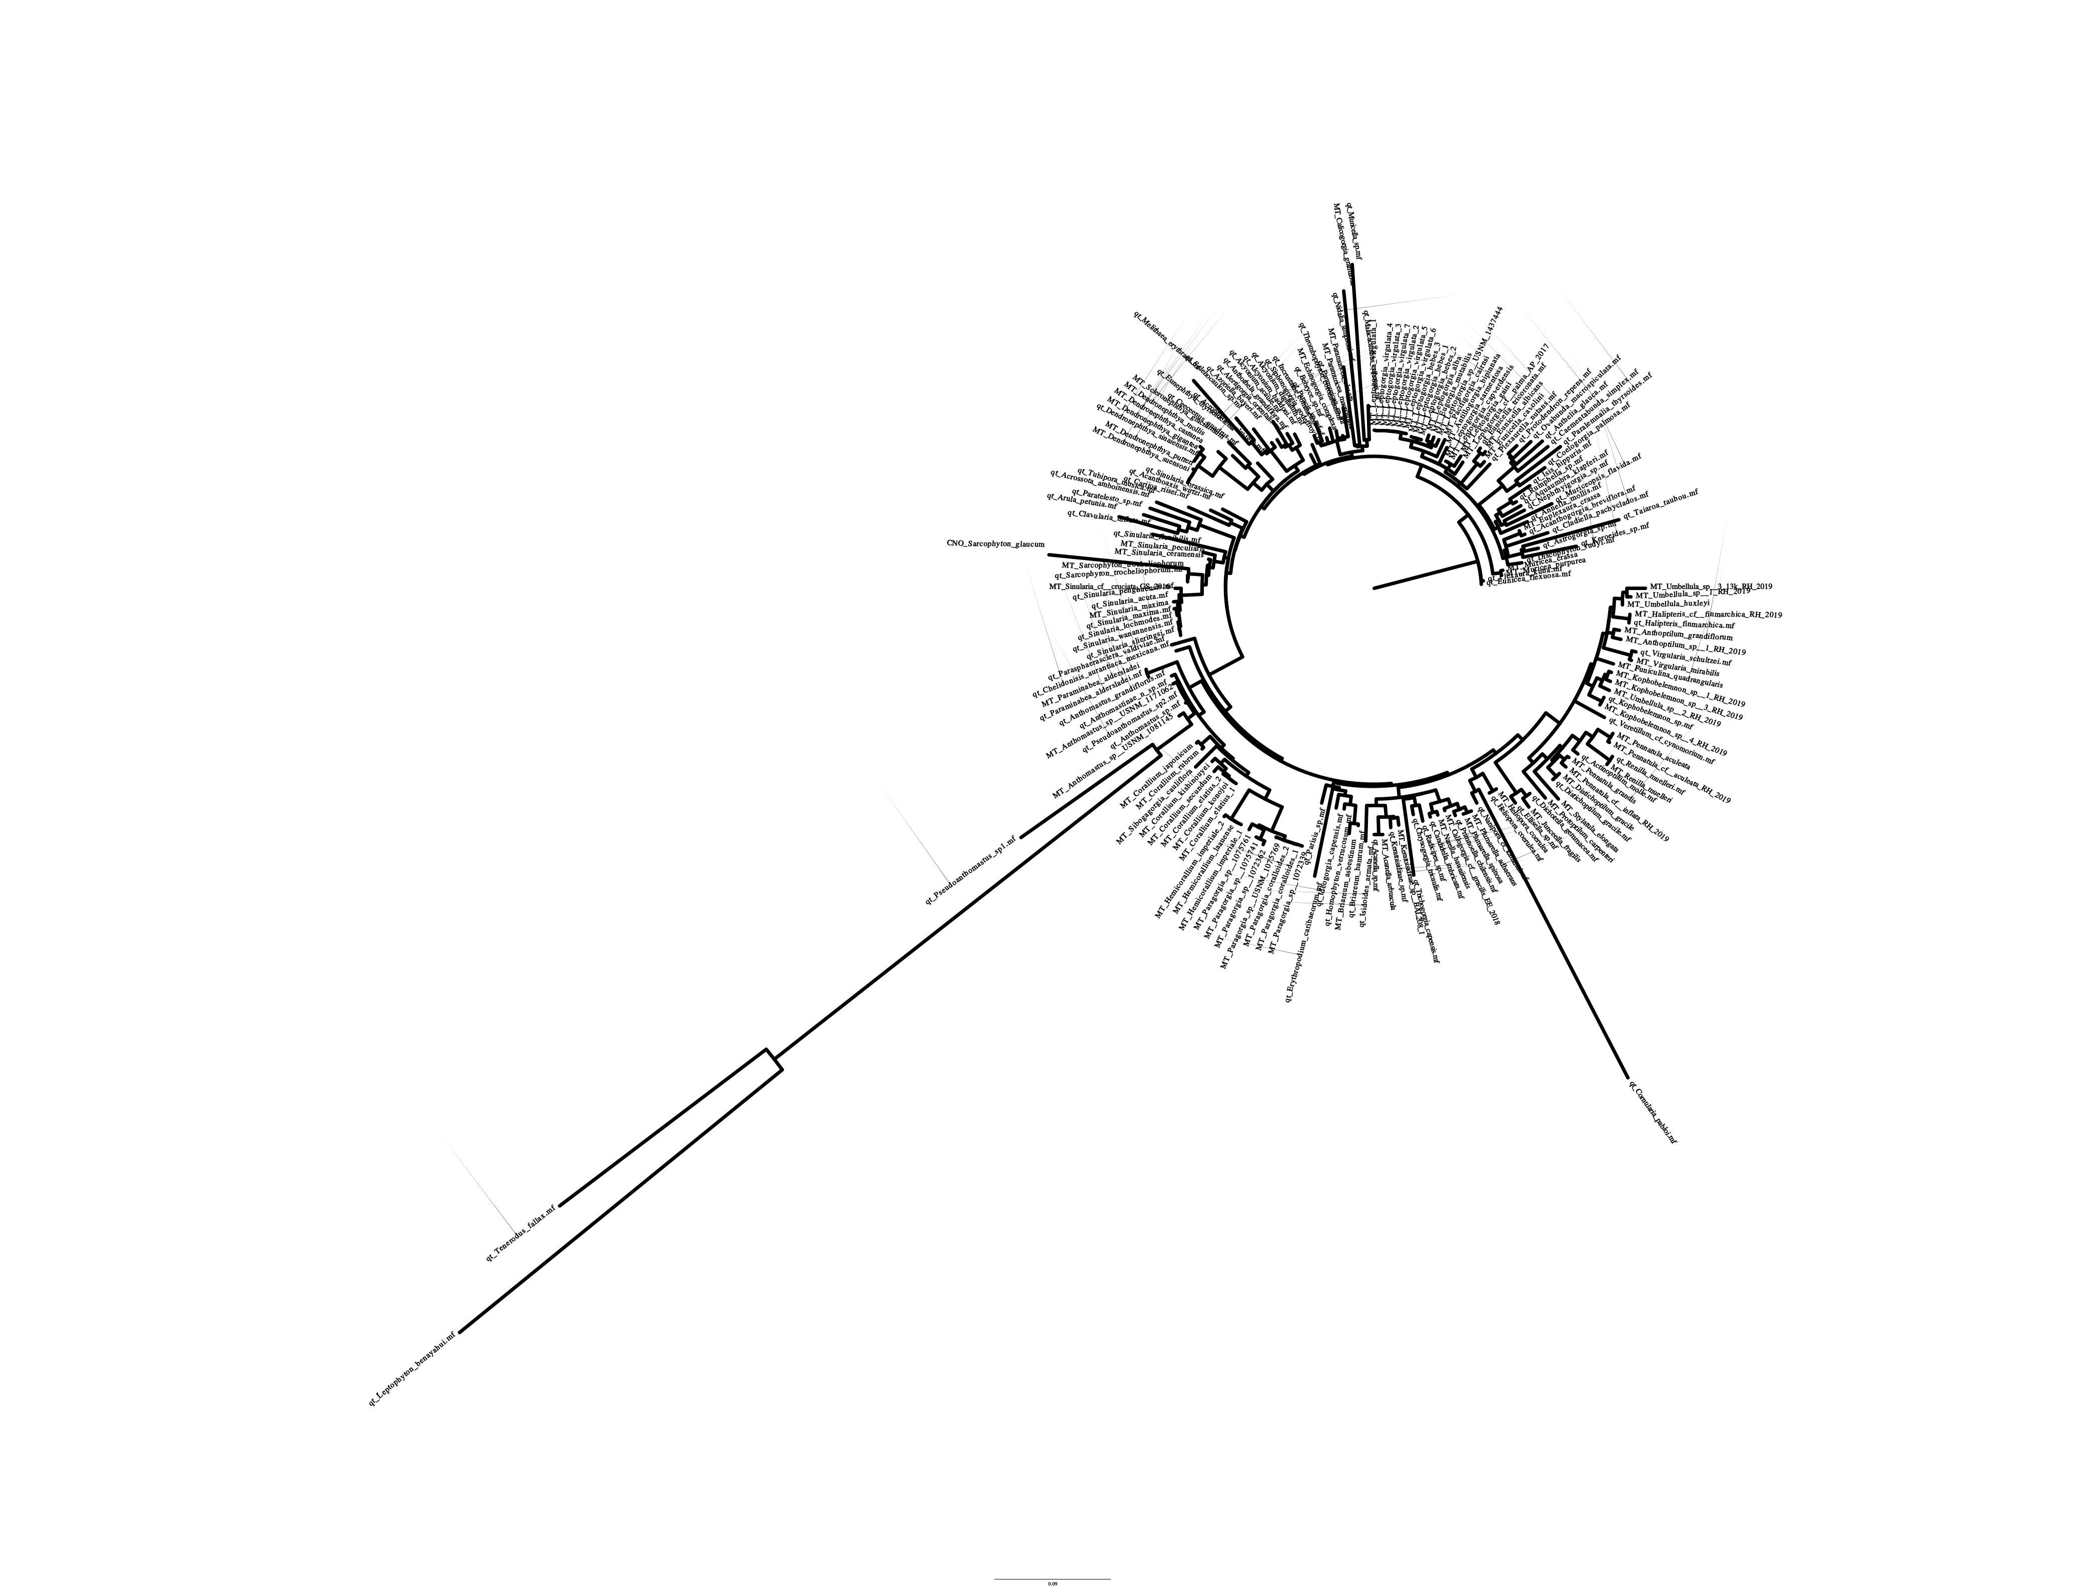Figure 7: COX3 gene tree with transformed branch lengths (left) and distance-based branch lengths (right).

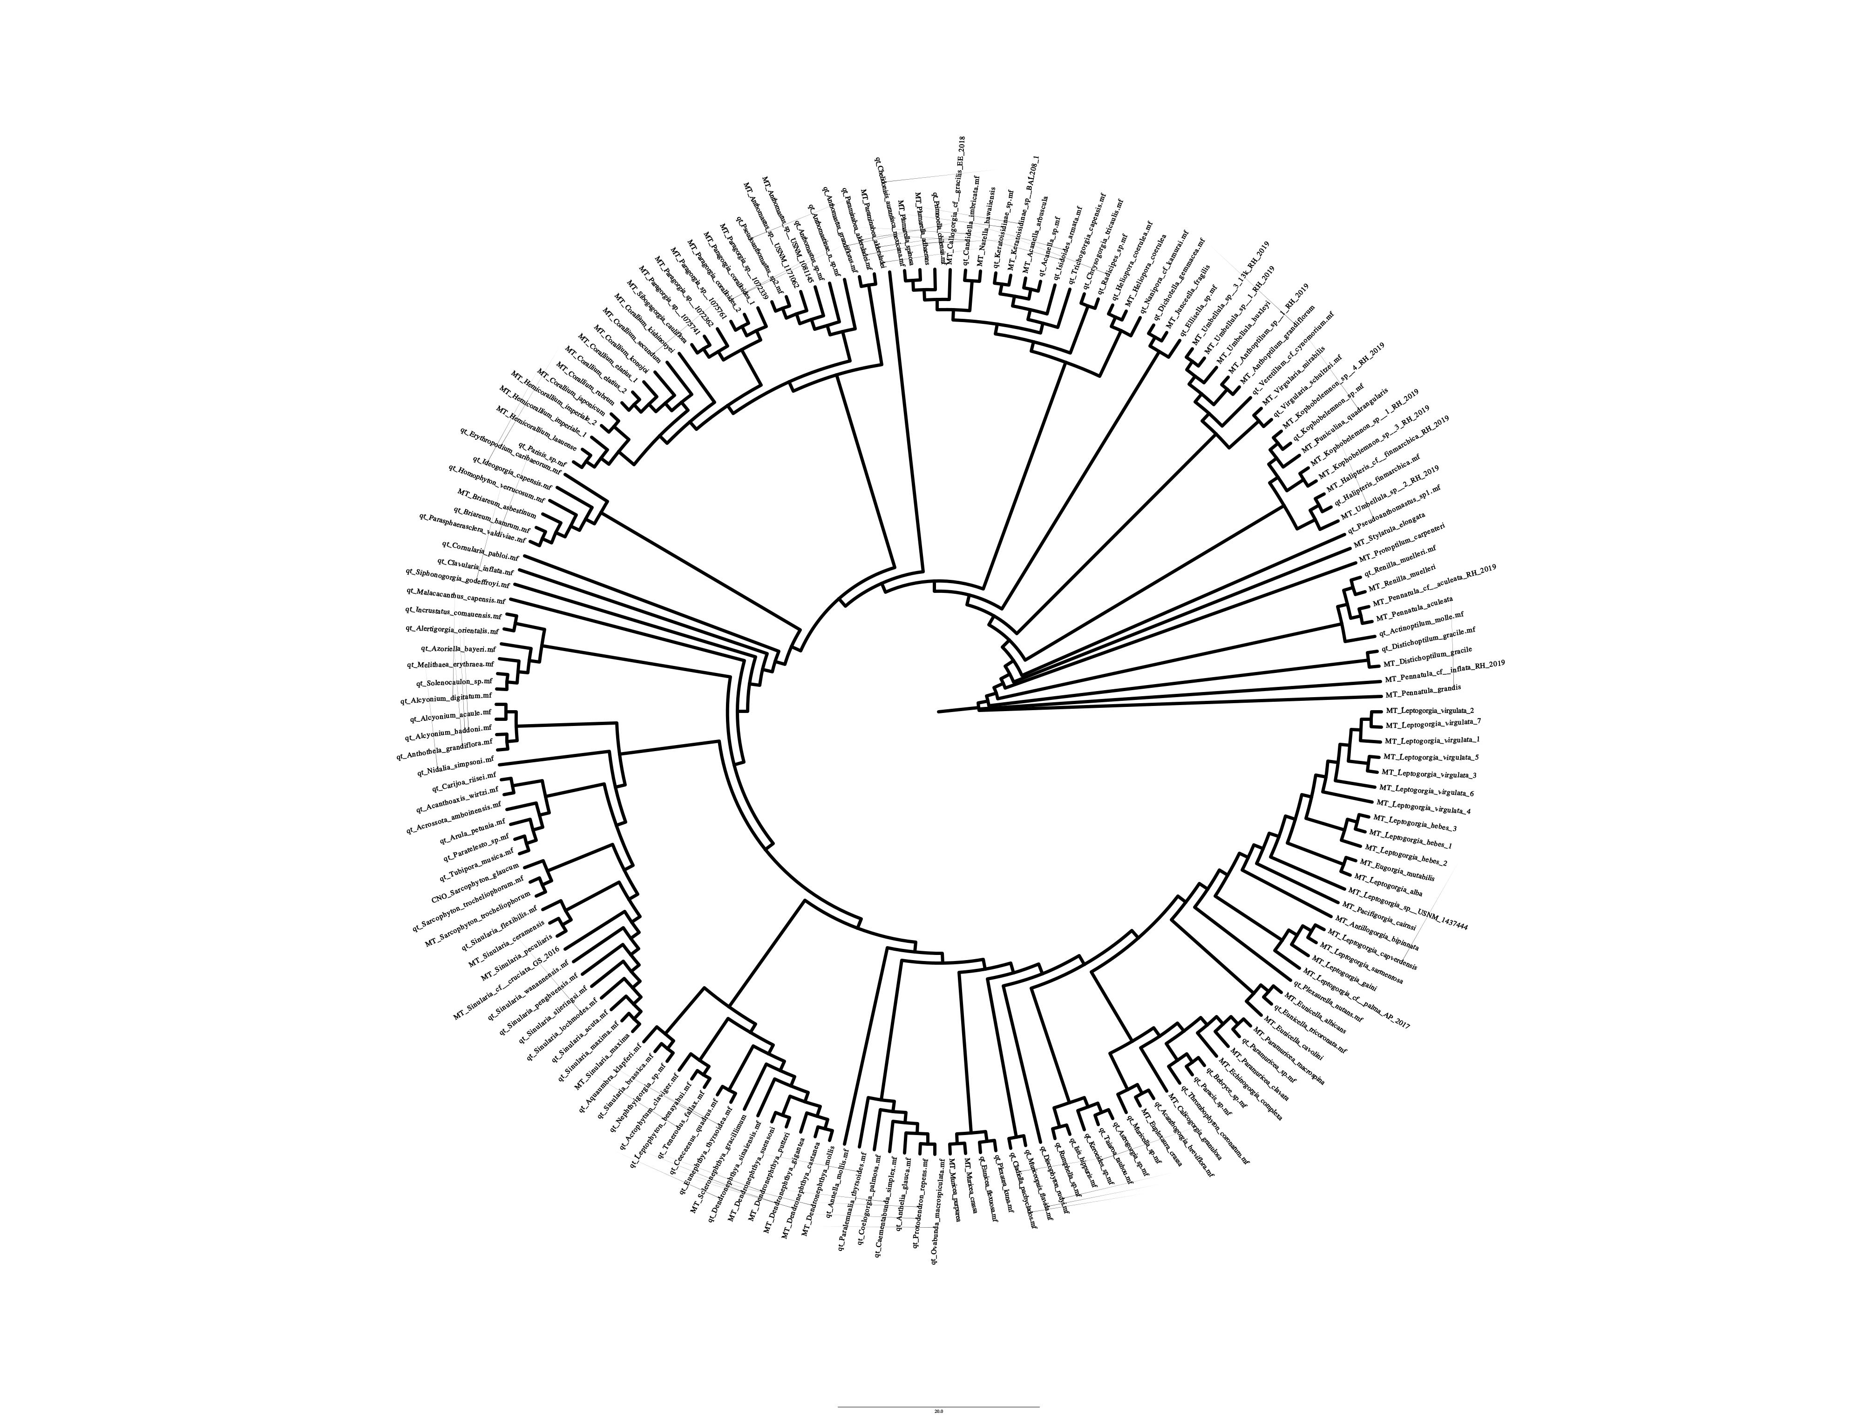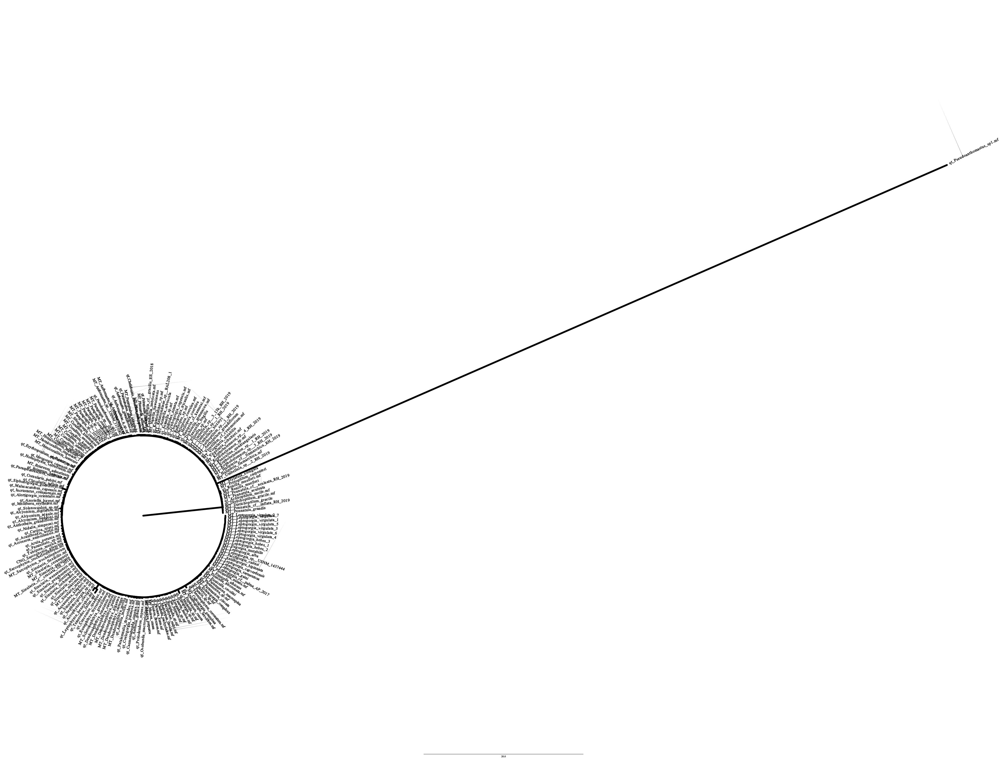Figure 8: mutS gene tree with transformed branch lengths (left) and distance-based branch lengths (right).

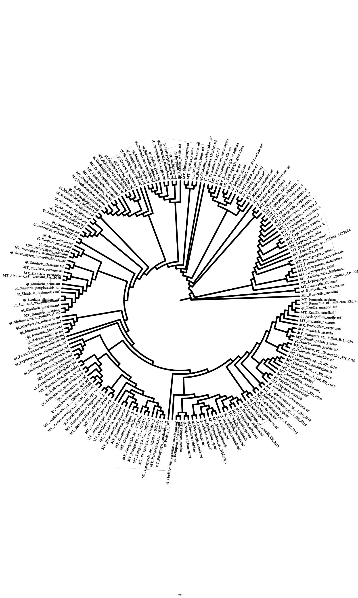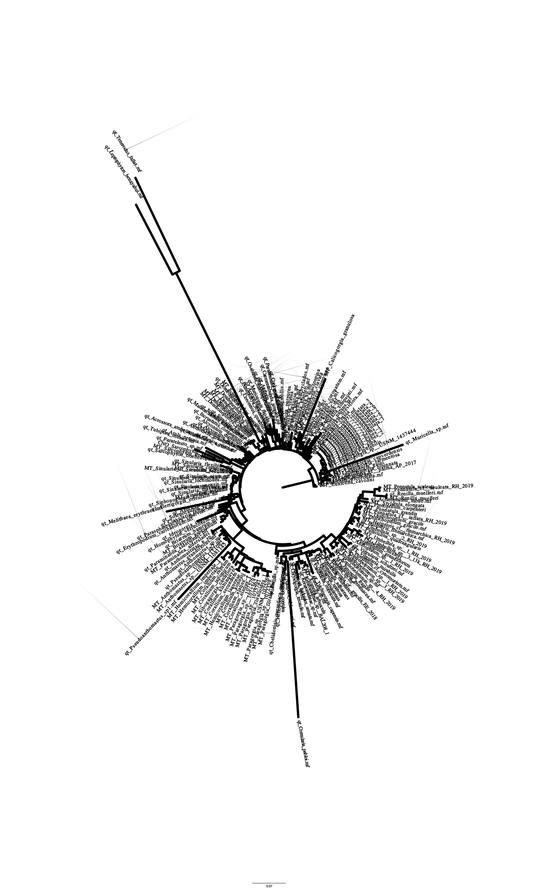

Figure 9: NAD1 gene tree with transformed branch lengths (left) and distance-based branch lengths (right).

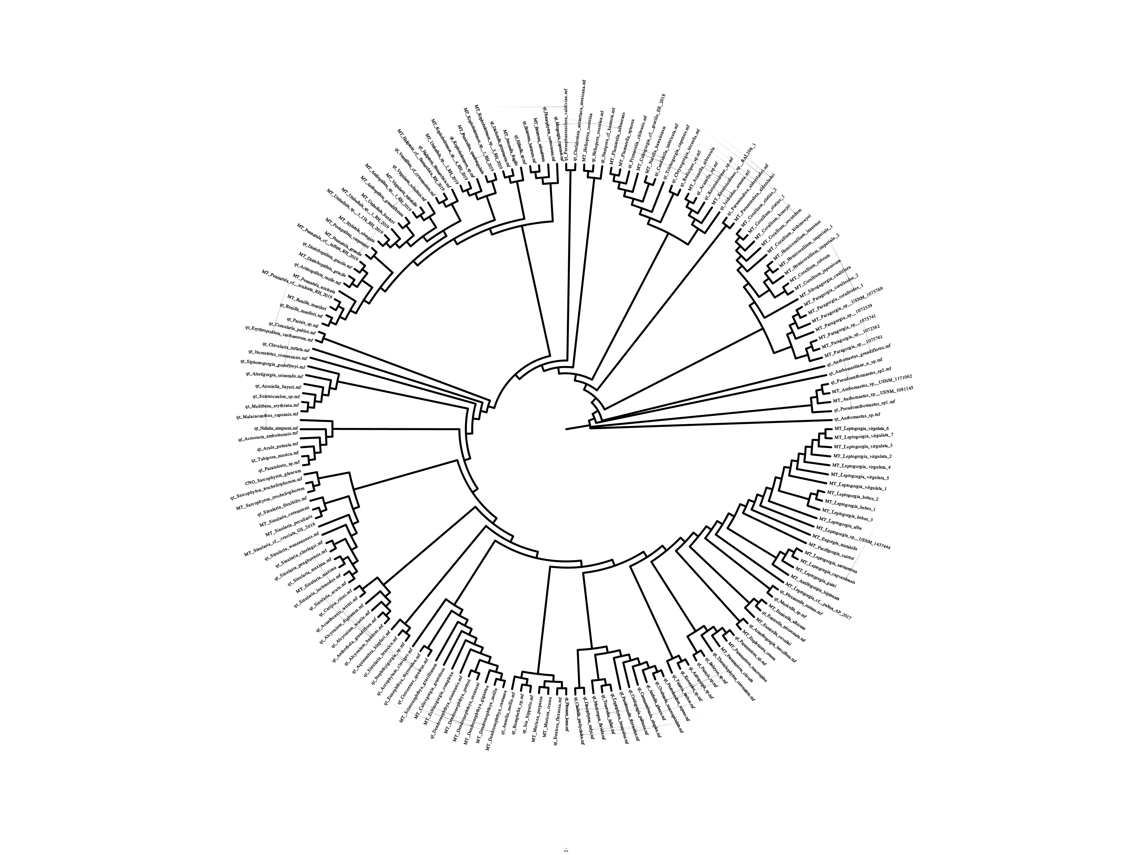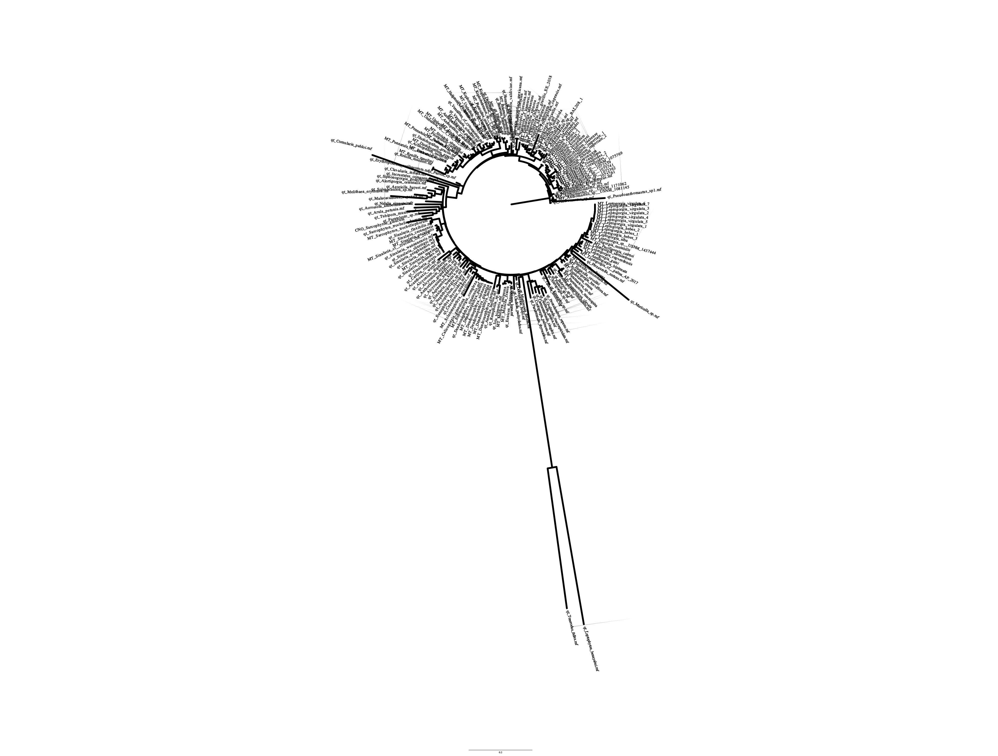

Figure 10: NAD2 gene tree with transformed branch lengths (left) and distance-based branch lengths (right).

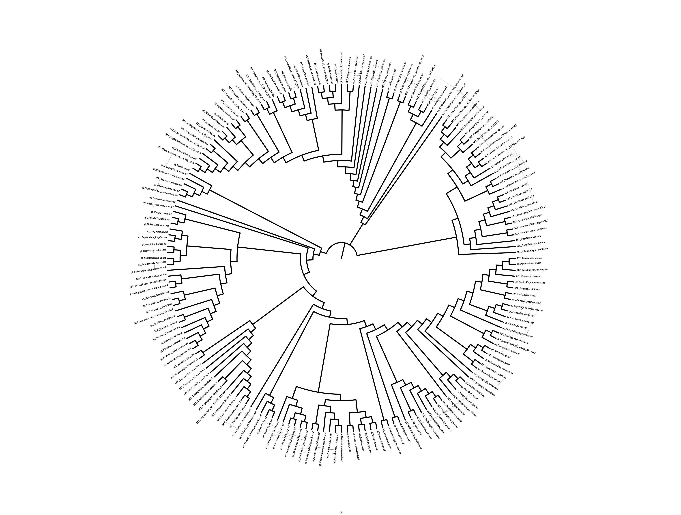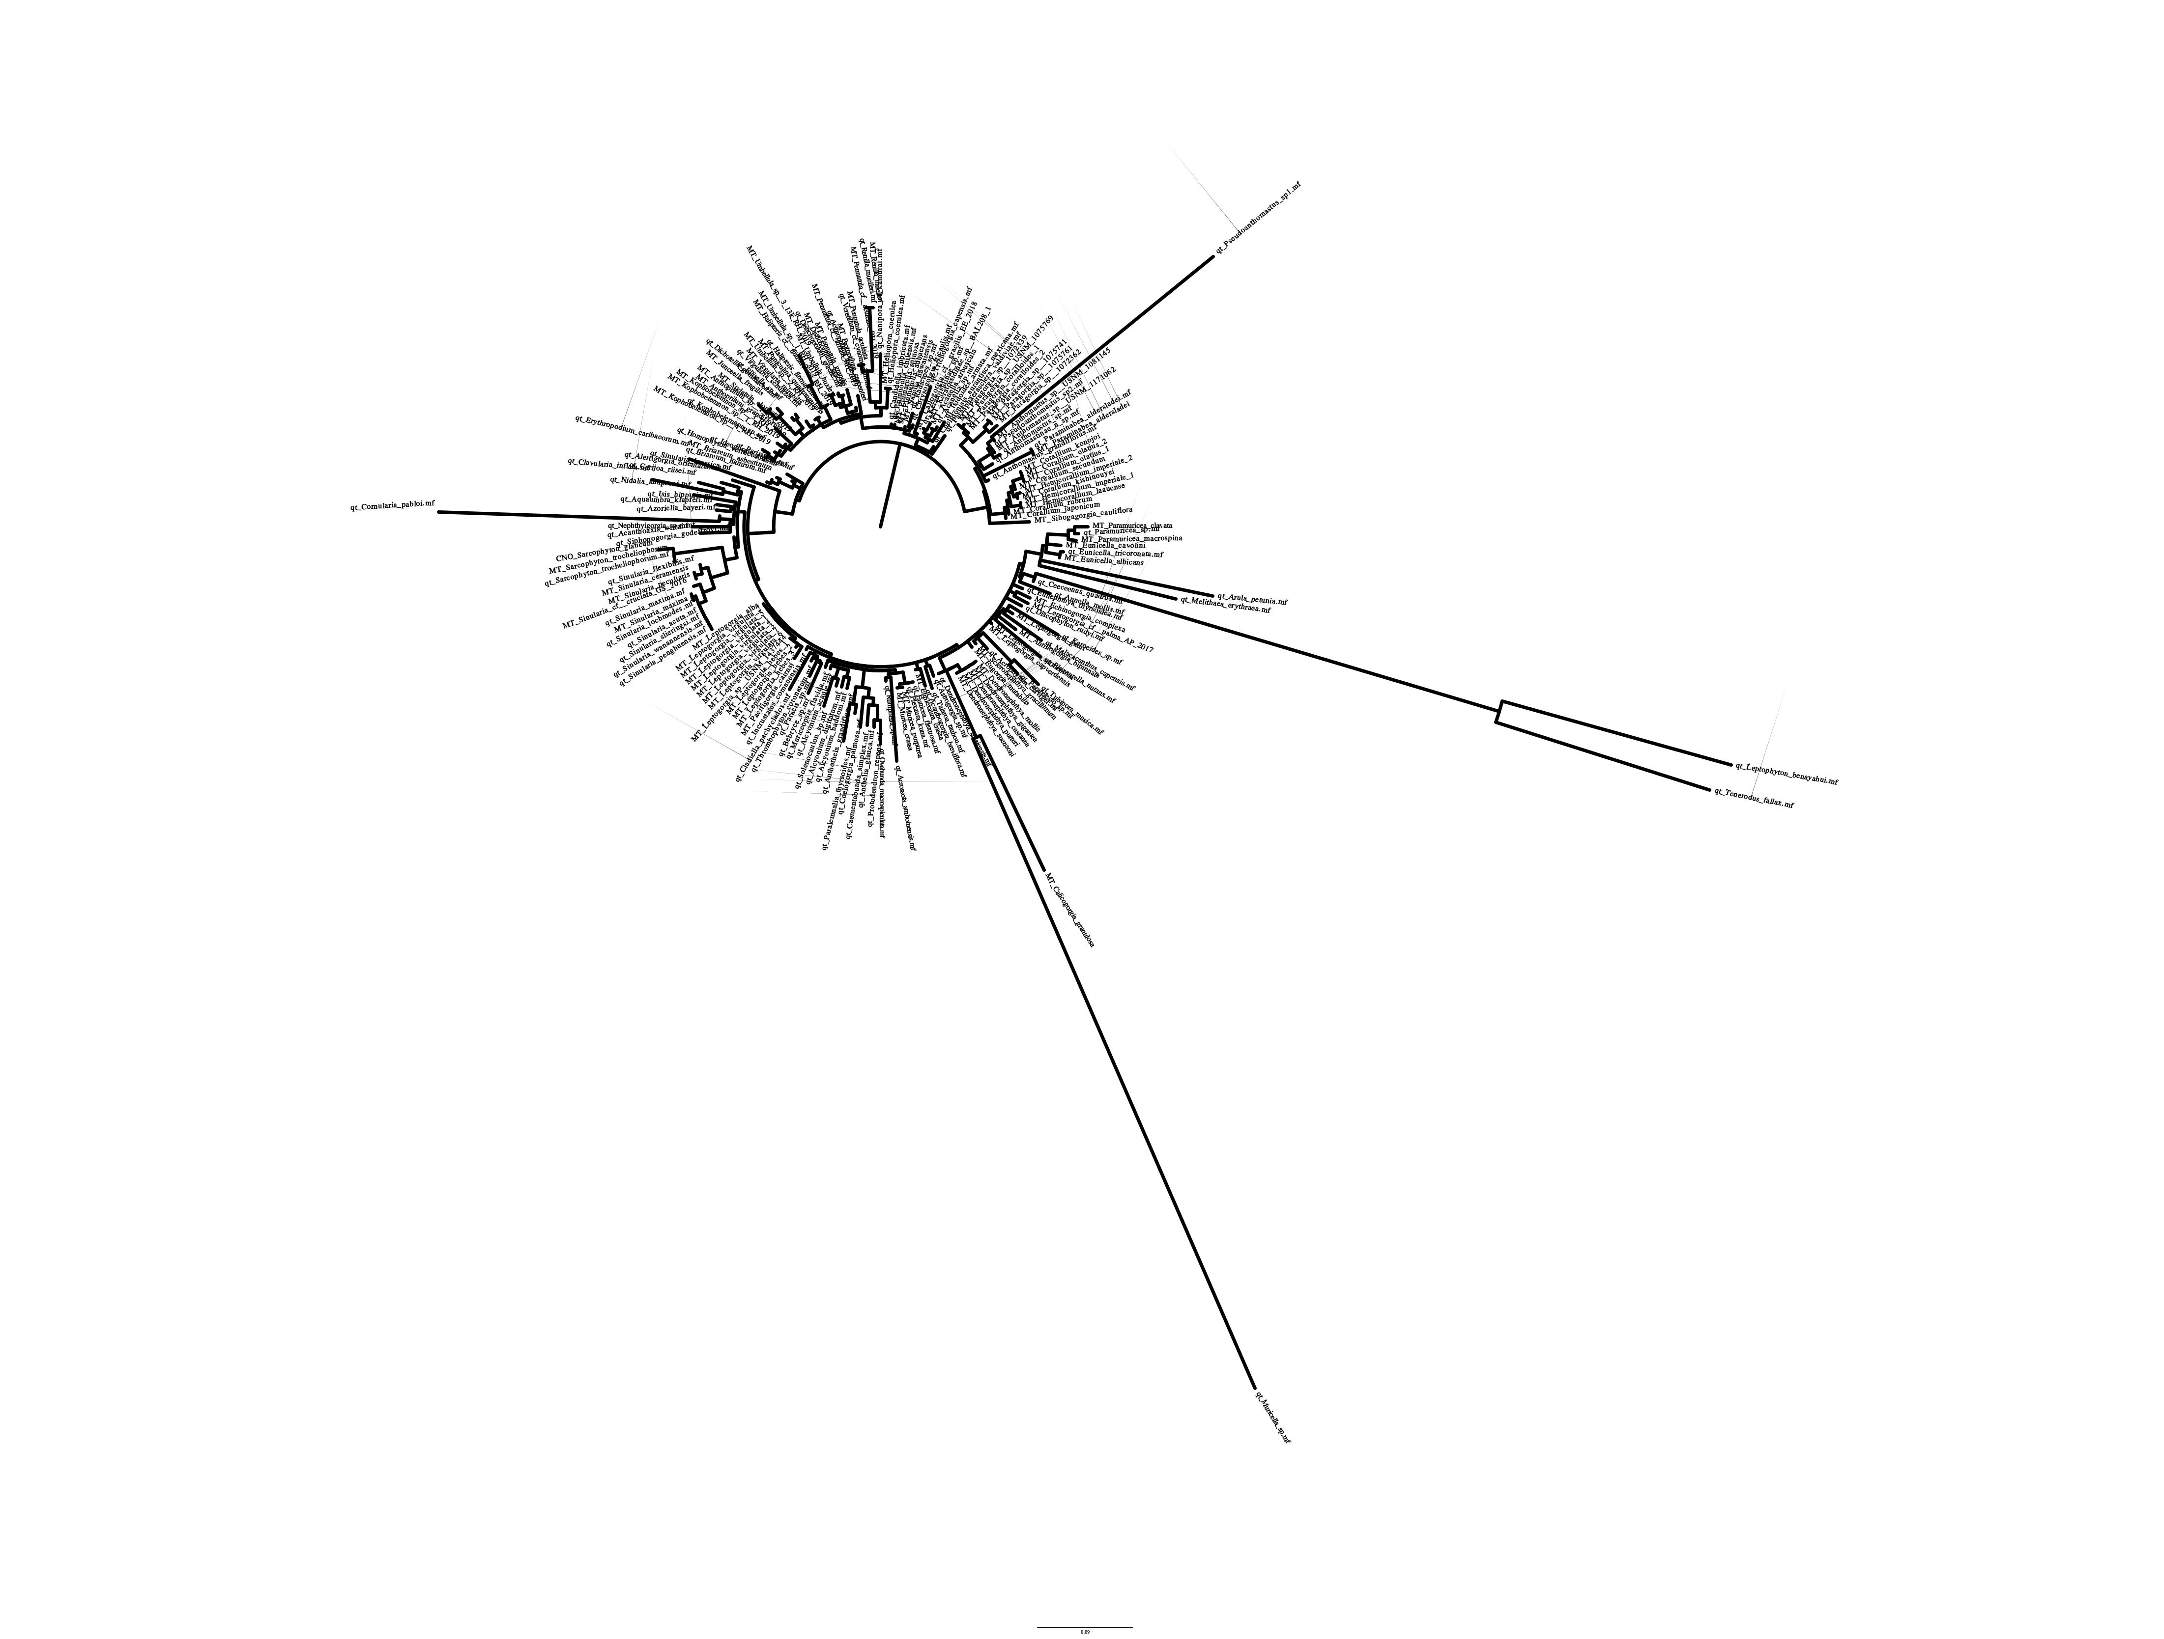Figure 11: NAD3 gene tree with transformed branch lengths (left) and distance-based branch lengths (right).

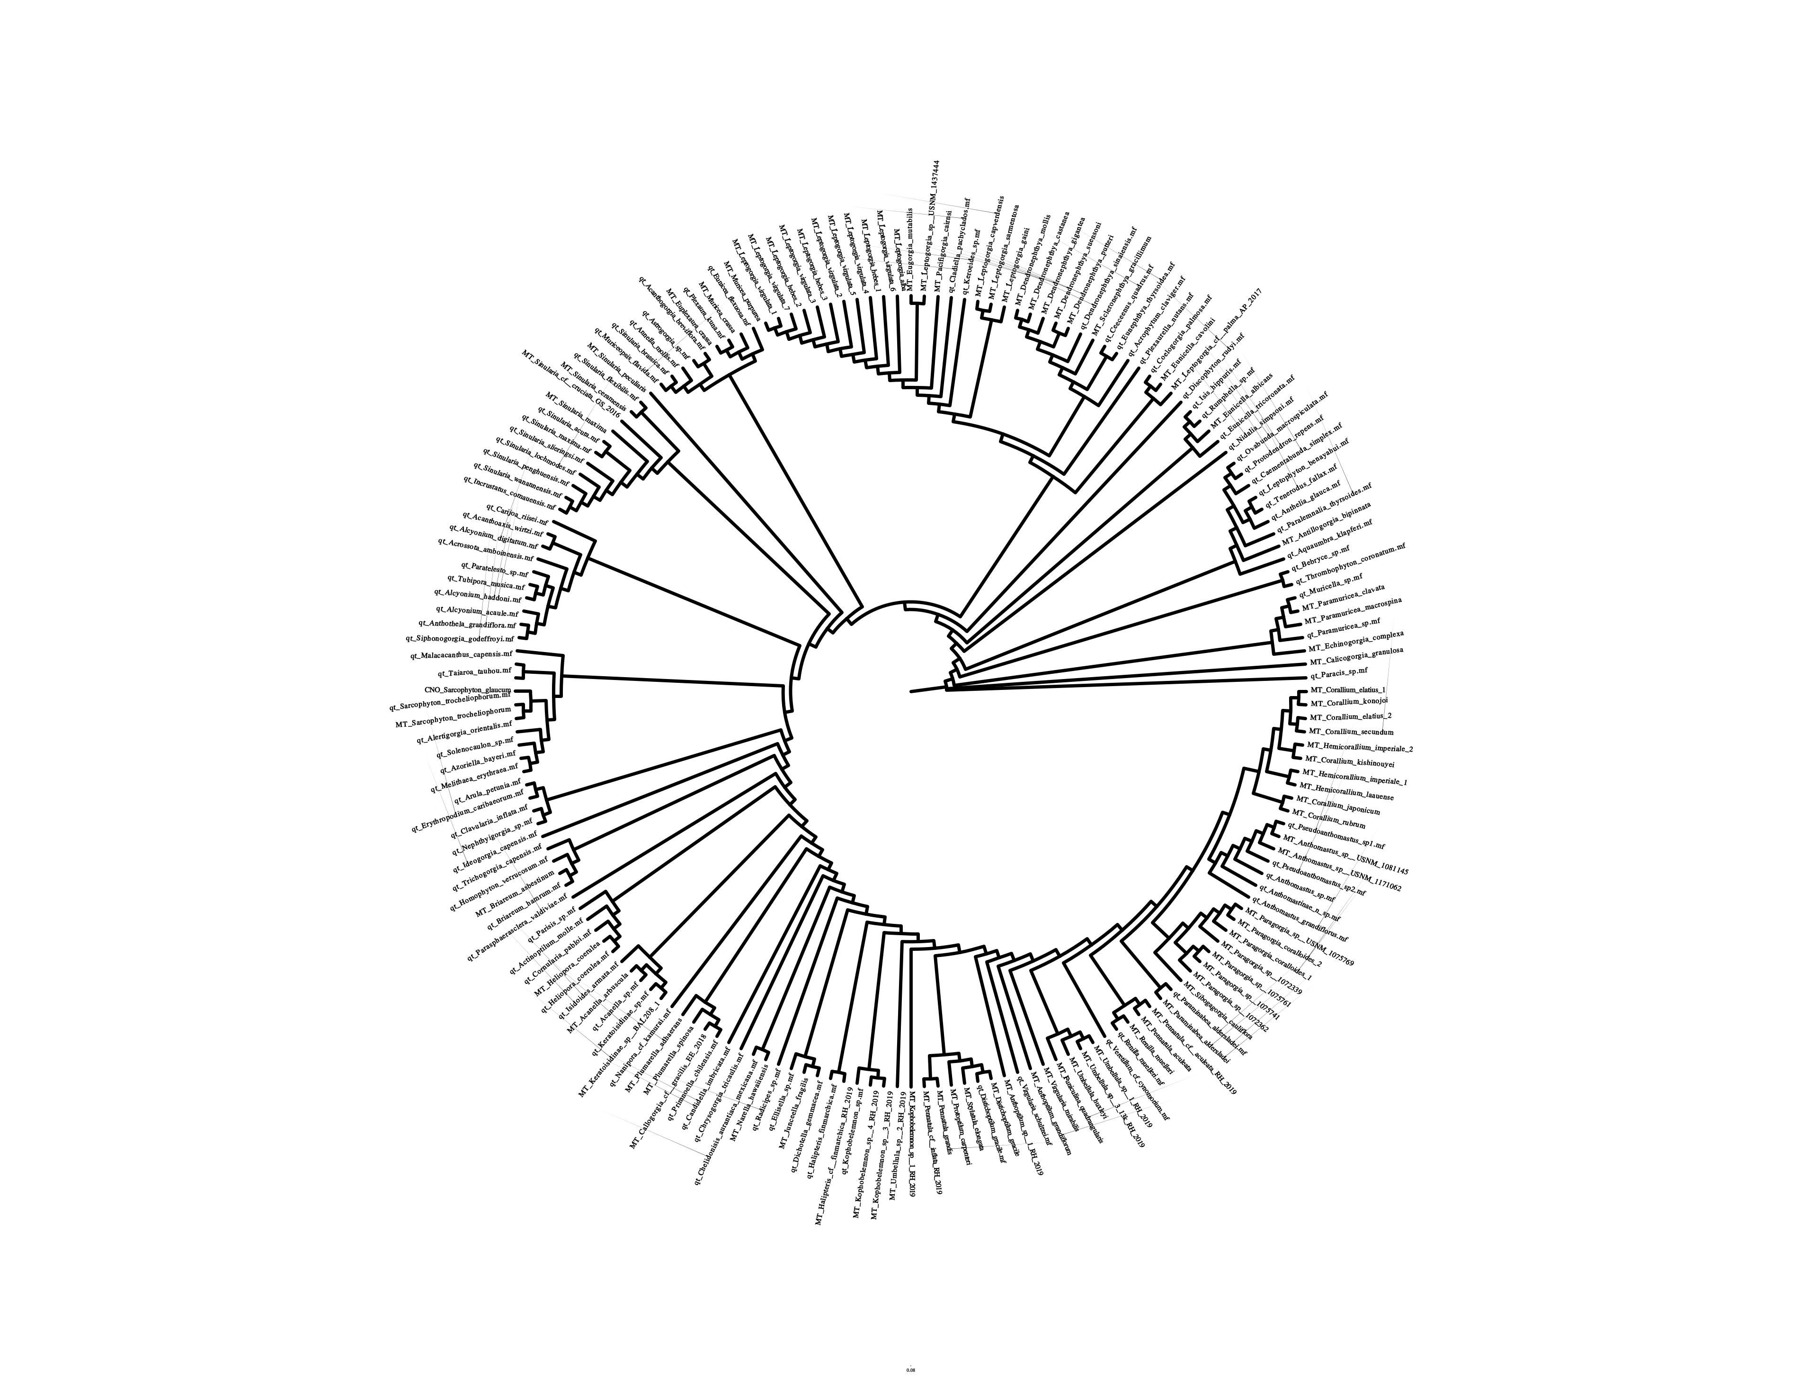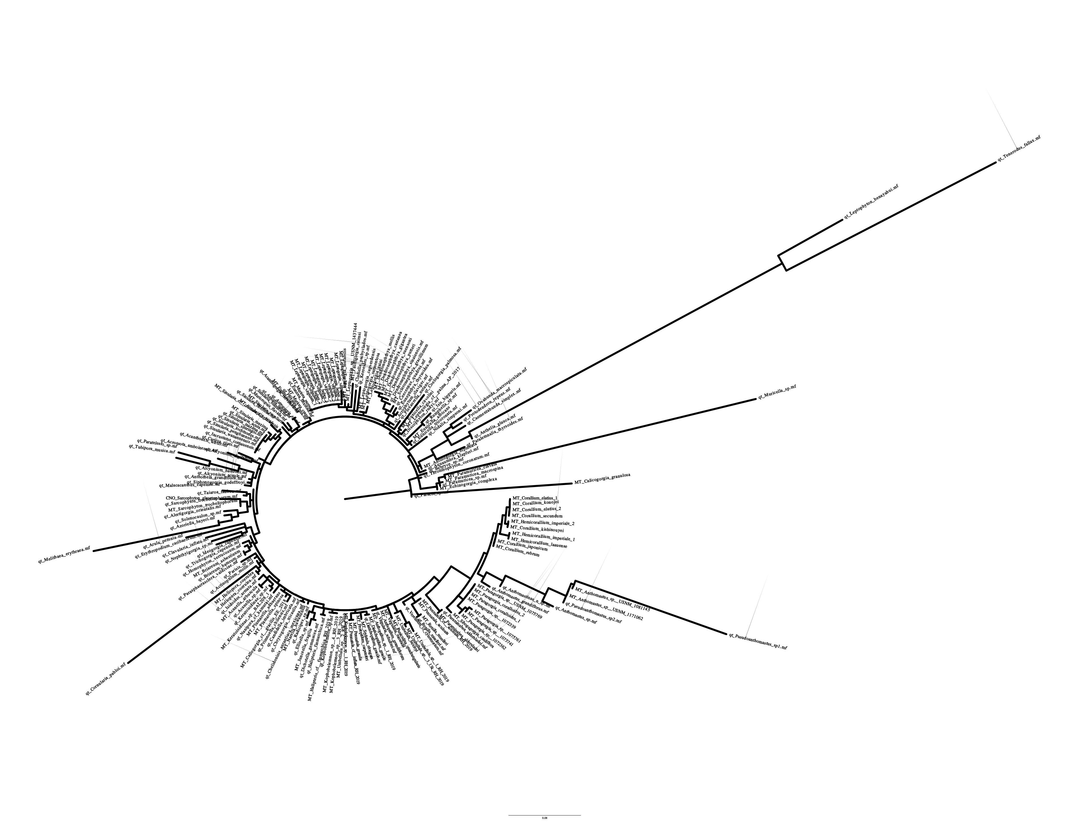Figure 12: NAD4L gene tree with transformed branch lengths (left) and distance-based branch lengths (right).

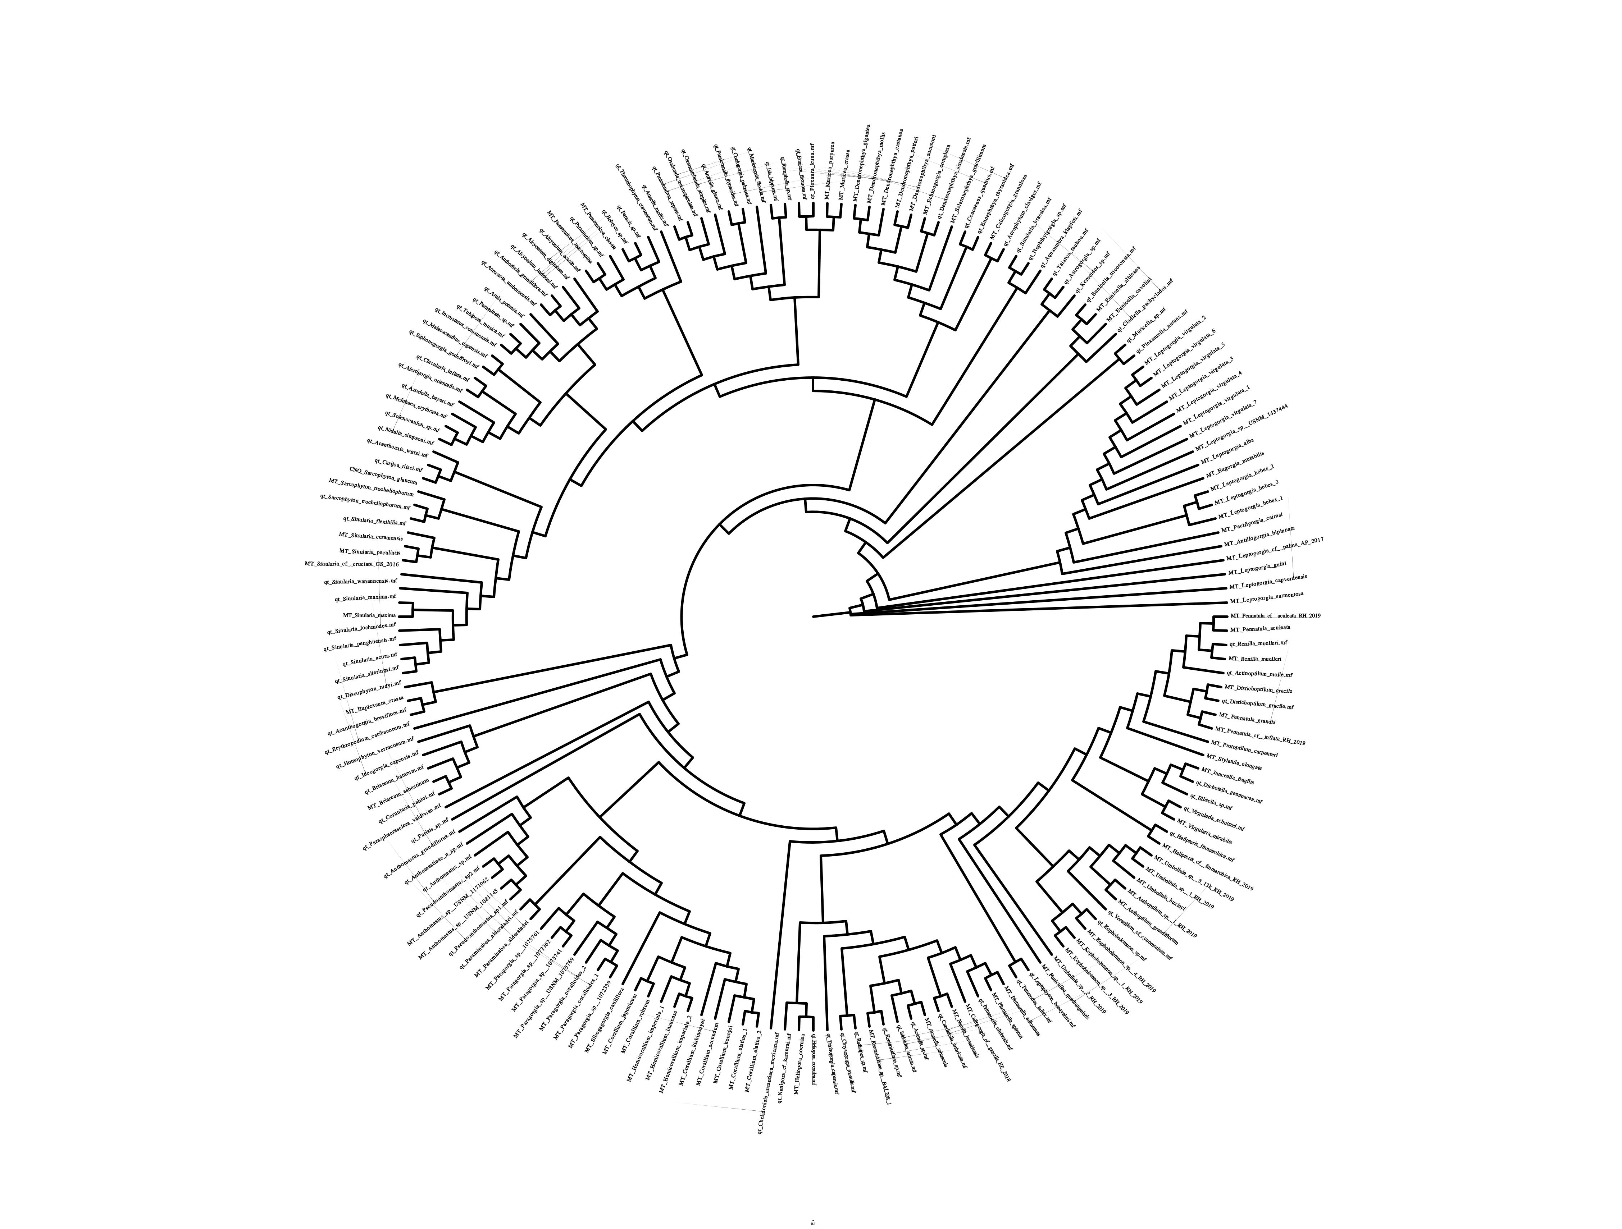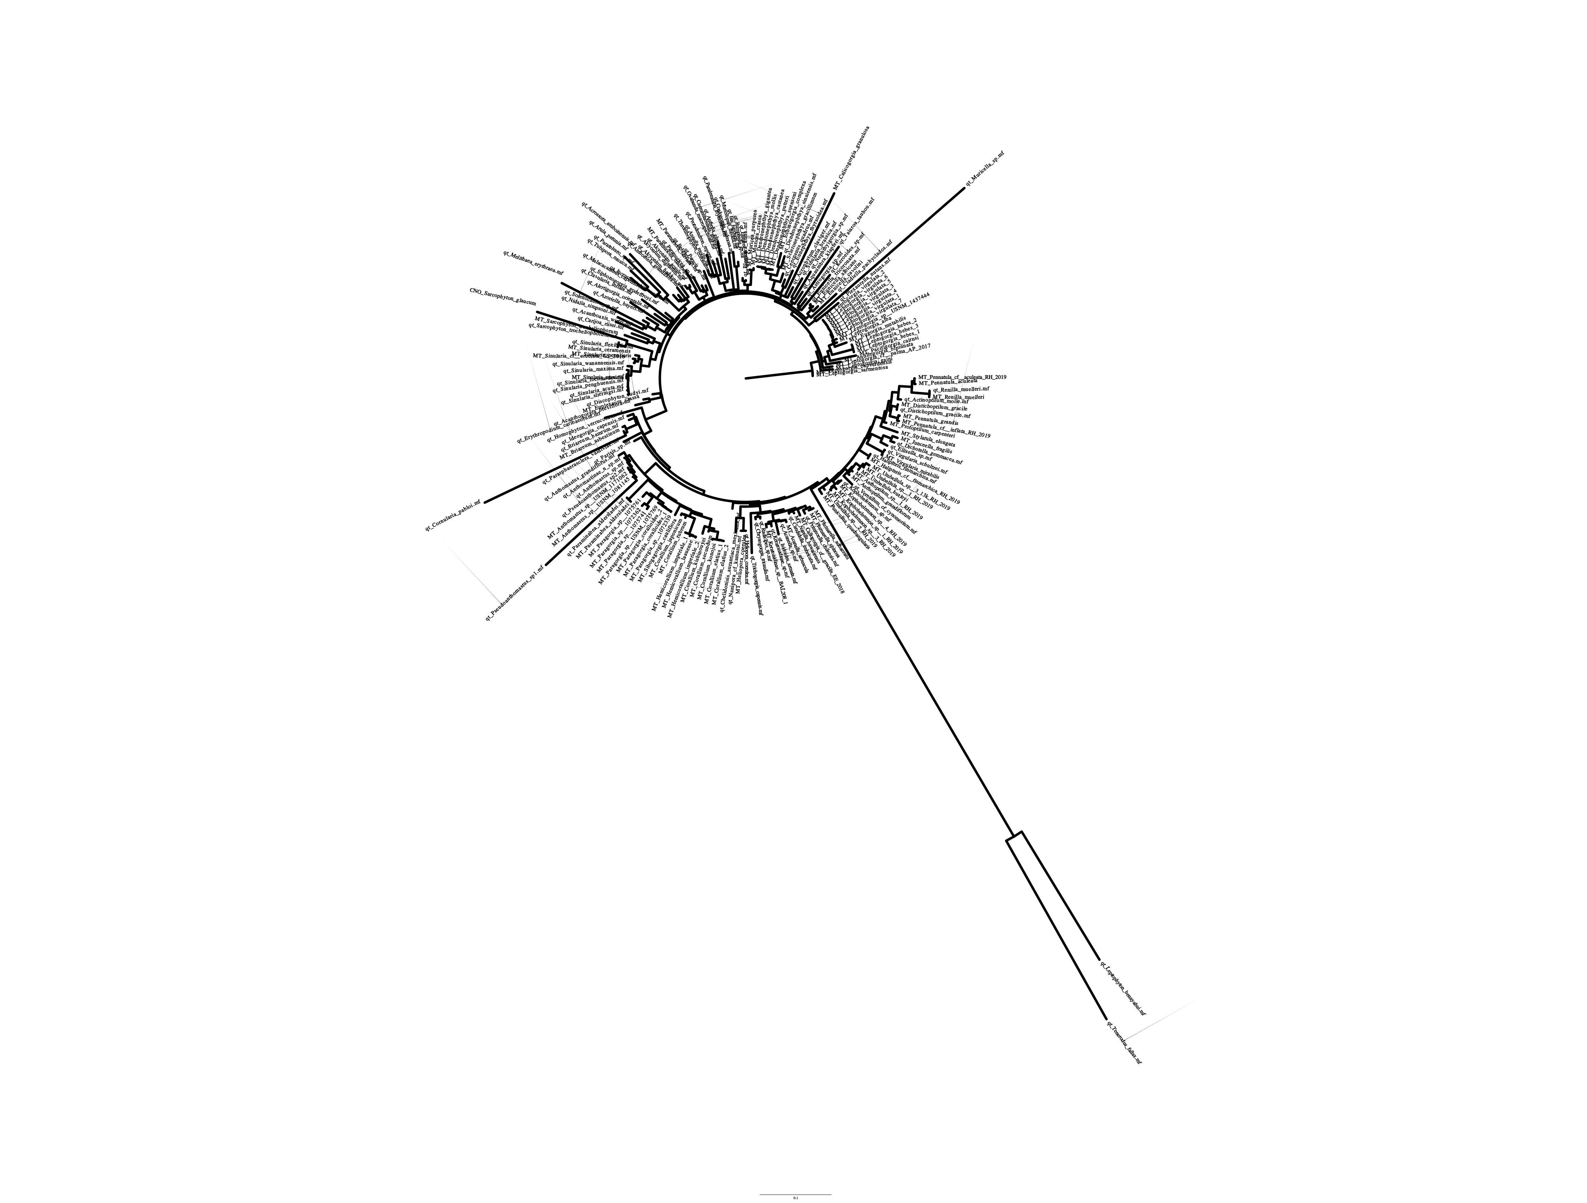

Figure 13: NAD4 gene tree with transformed branch lengths (left) and distance-based branch lengths (right).

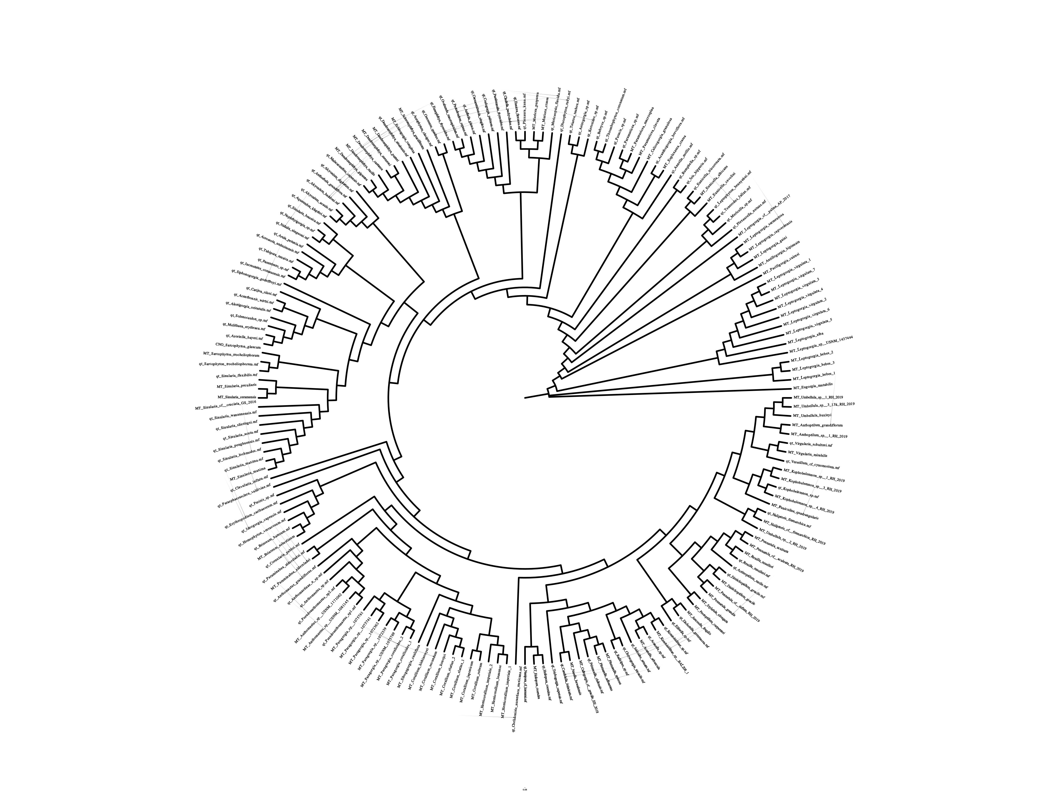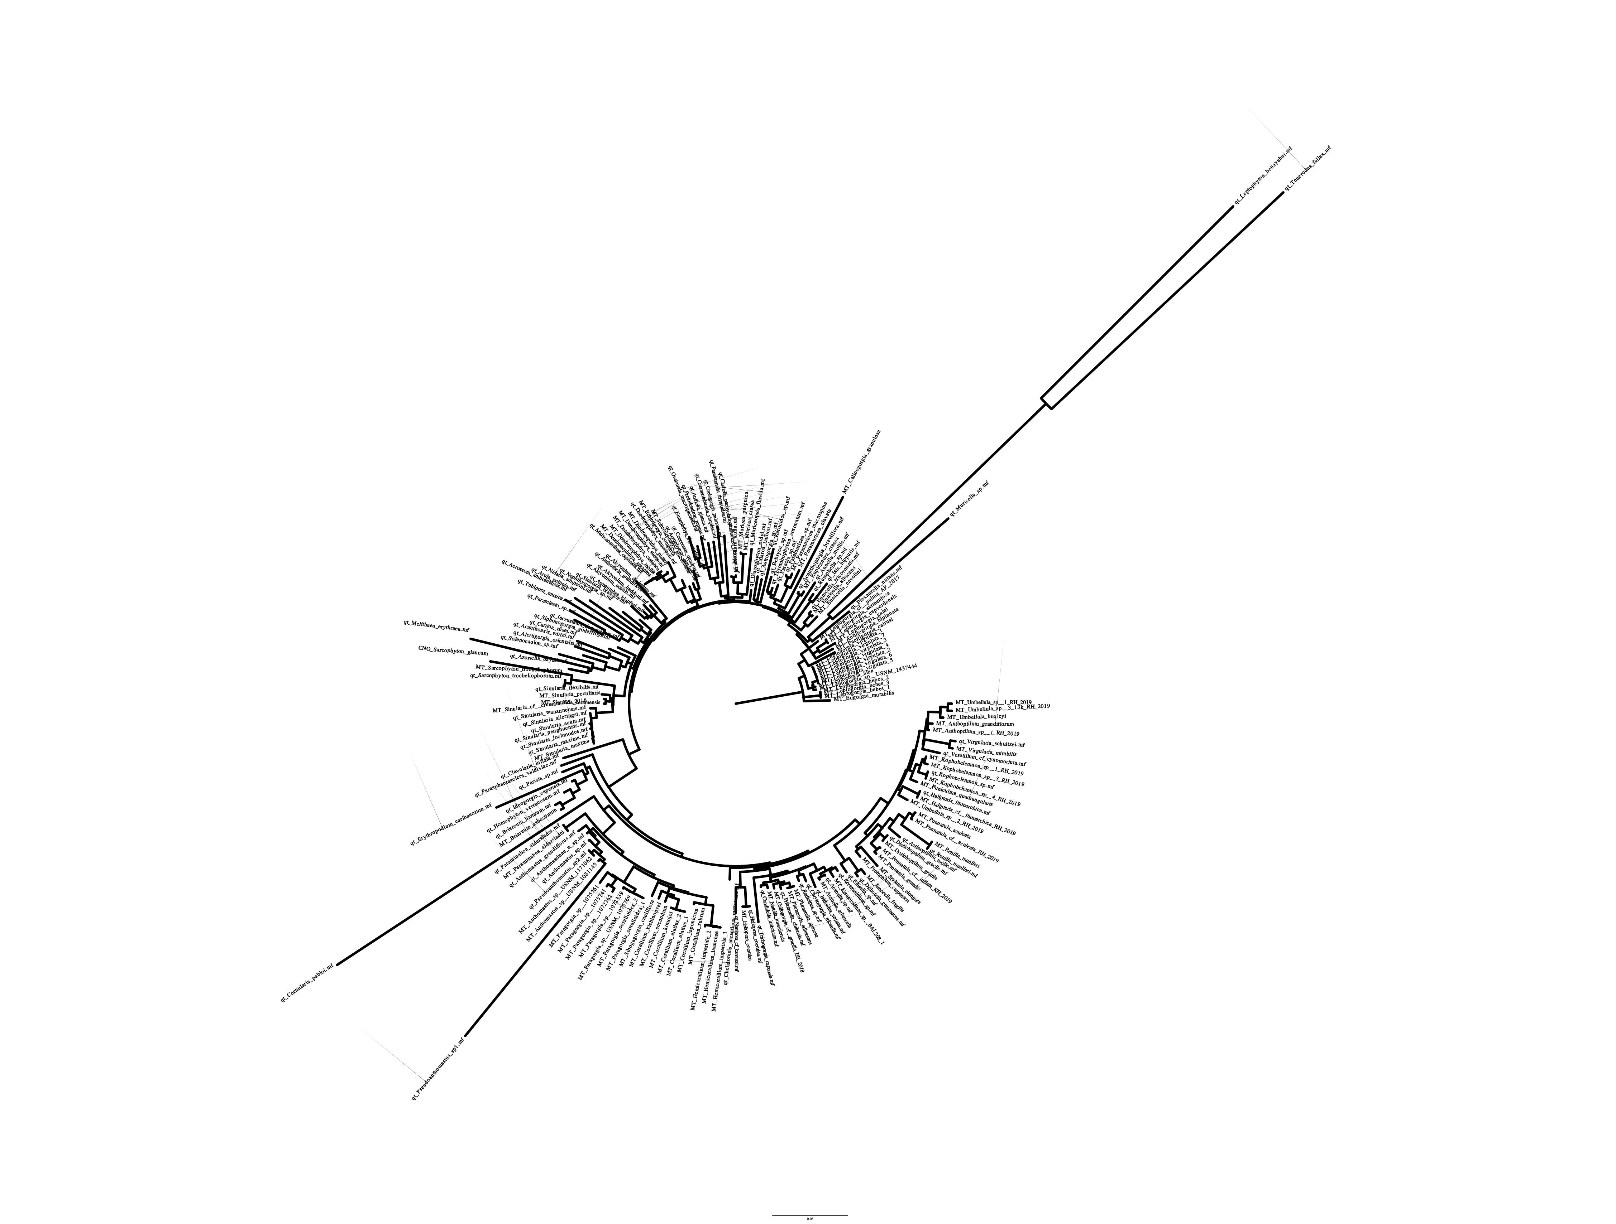Figure 14: NAD5 gene tree with transformed branch lengths (left) and distance-based branch lengths (right).

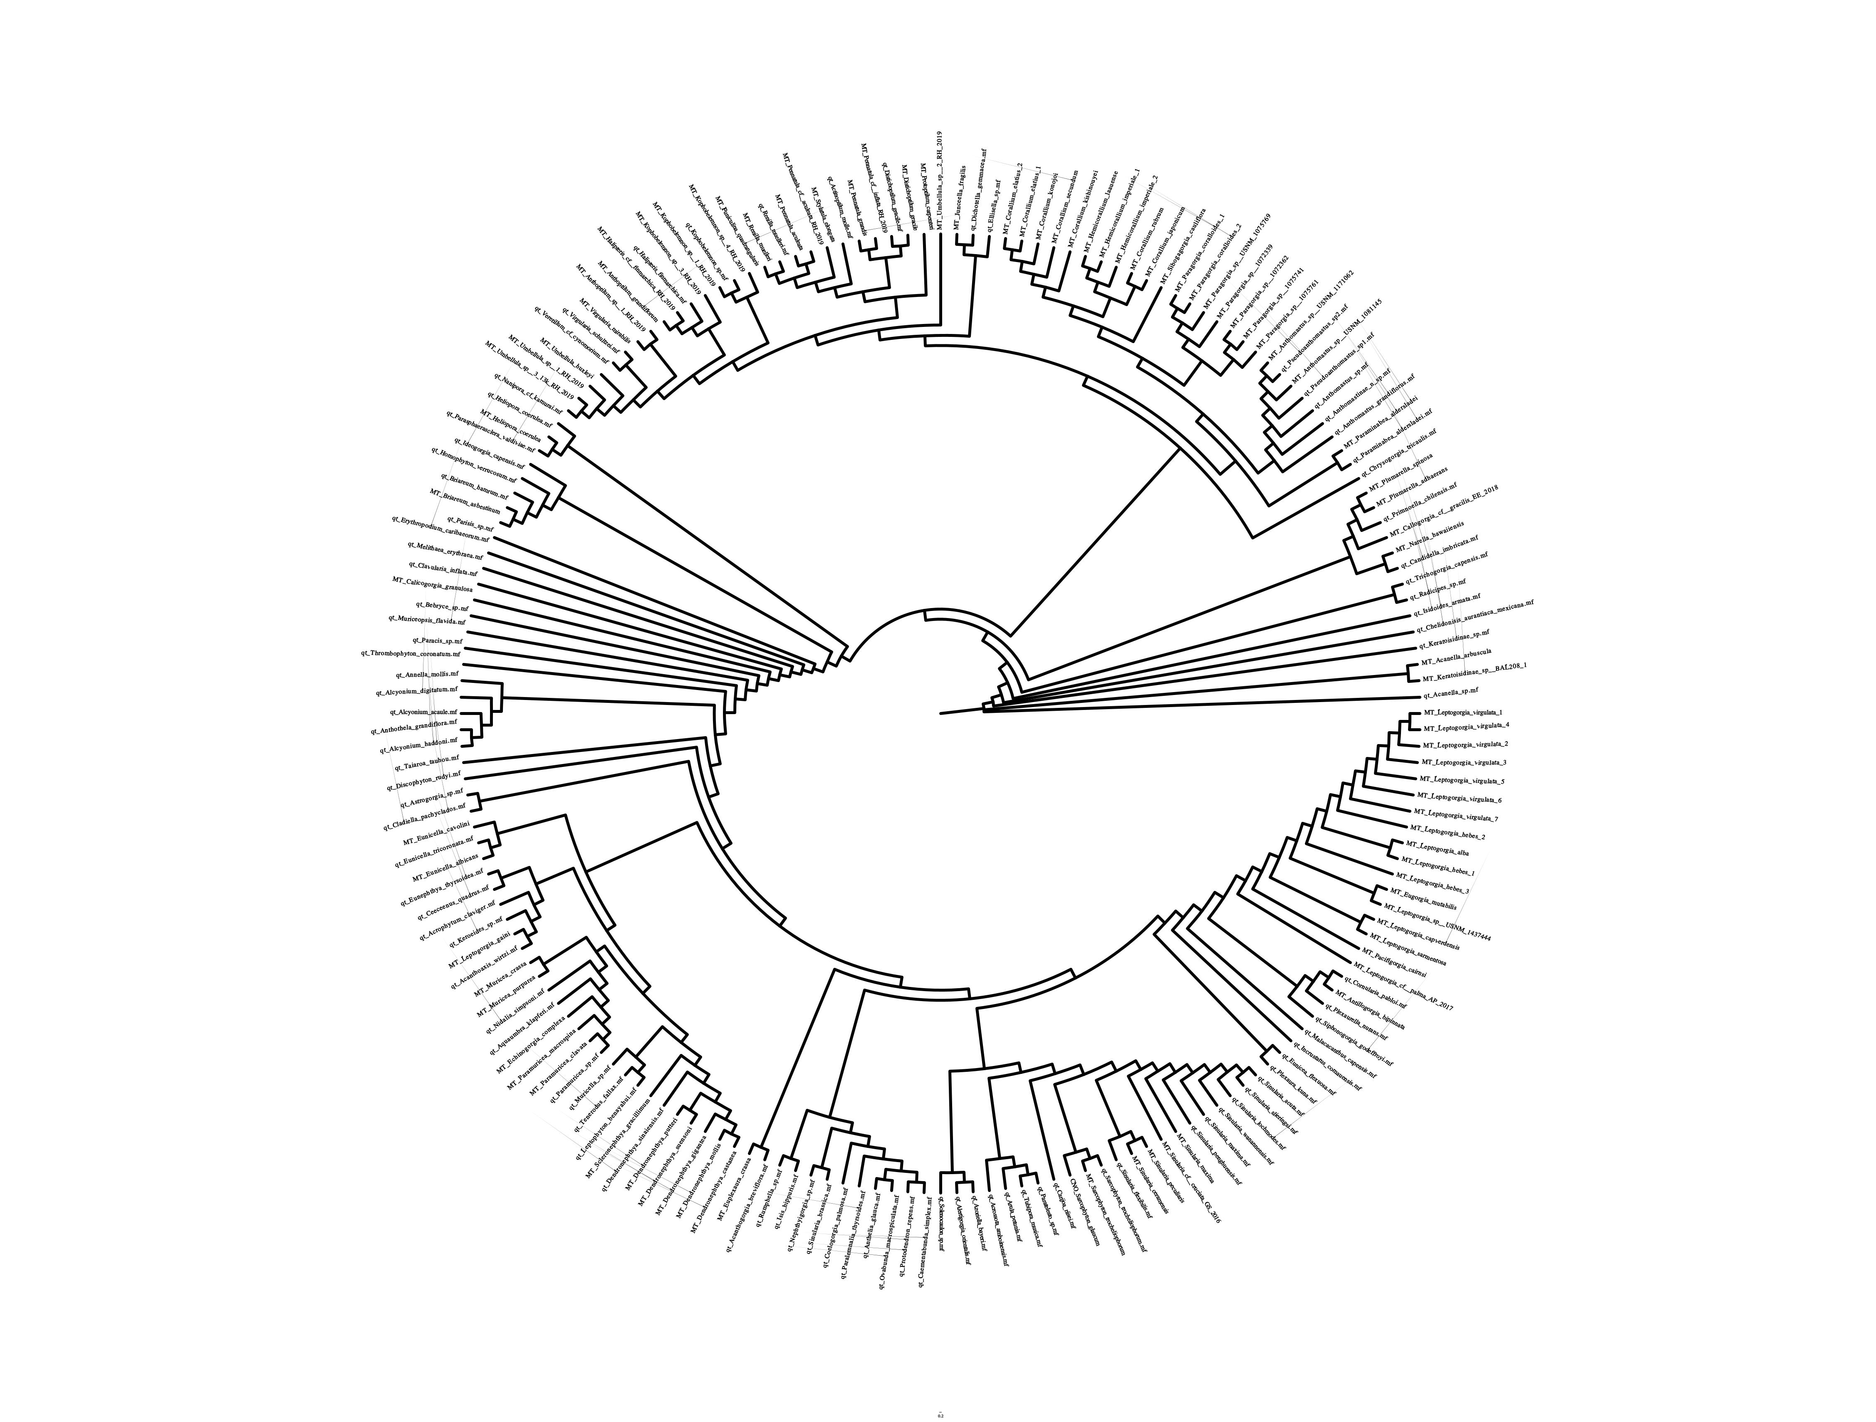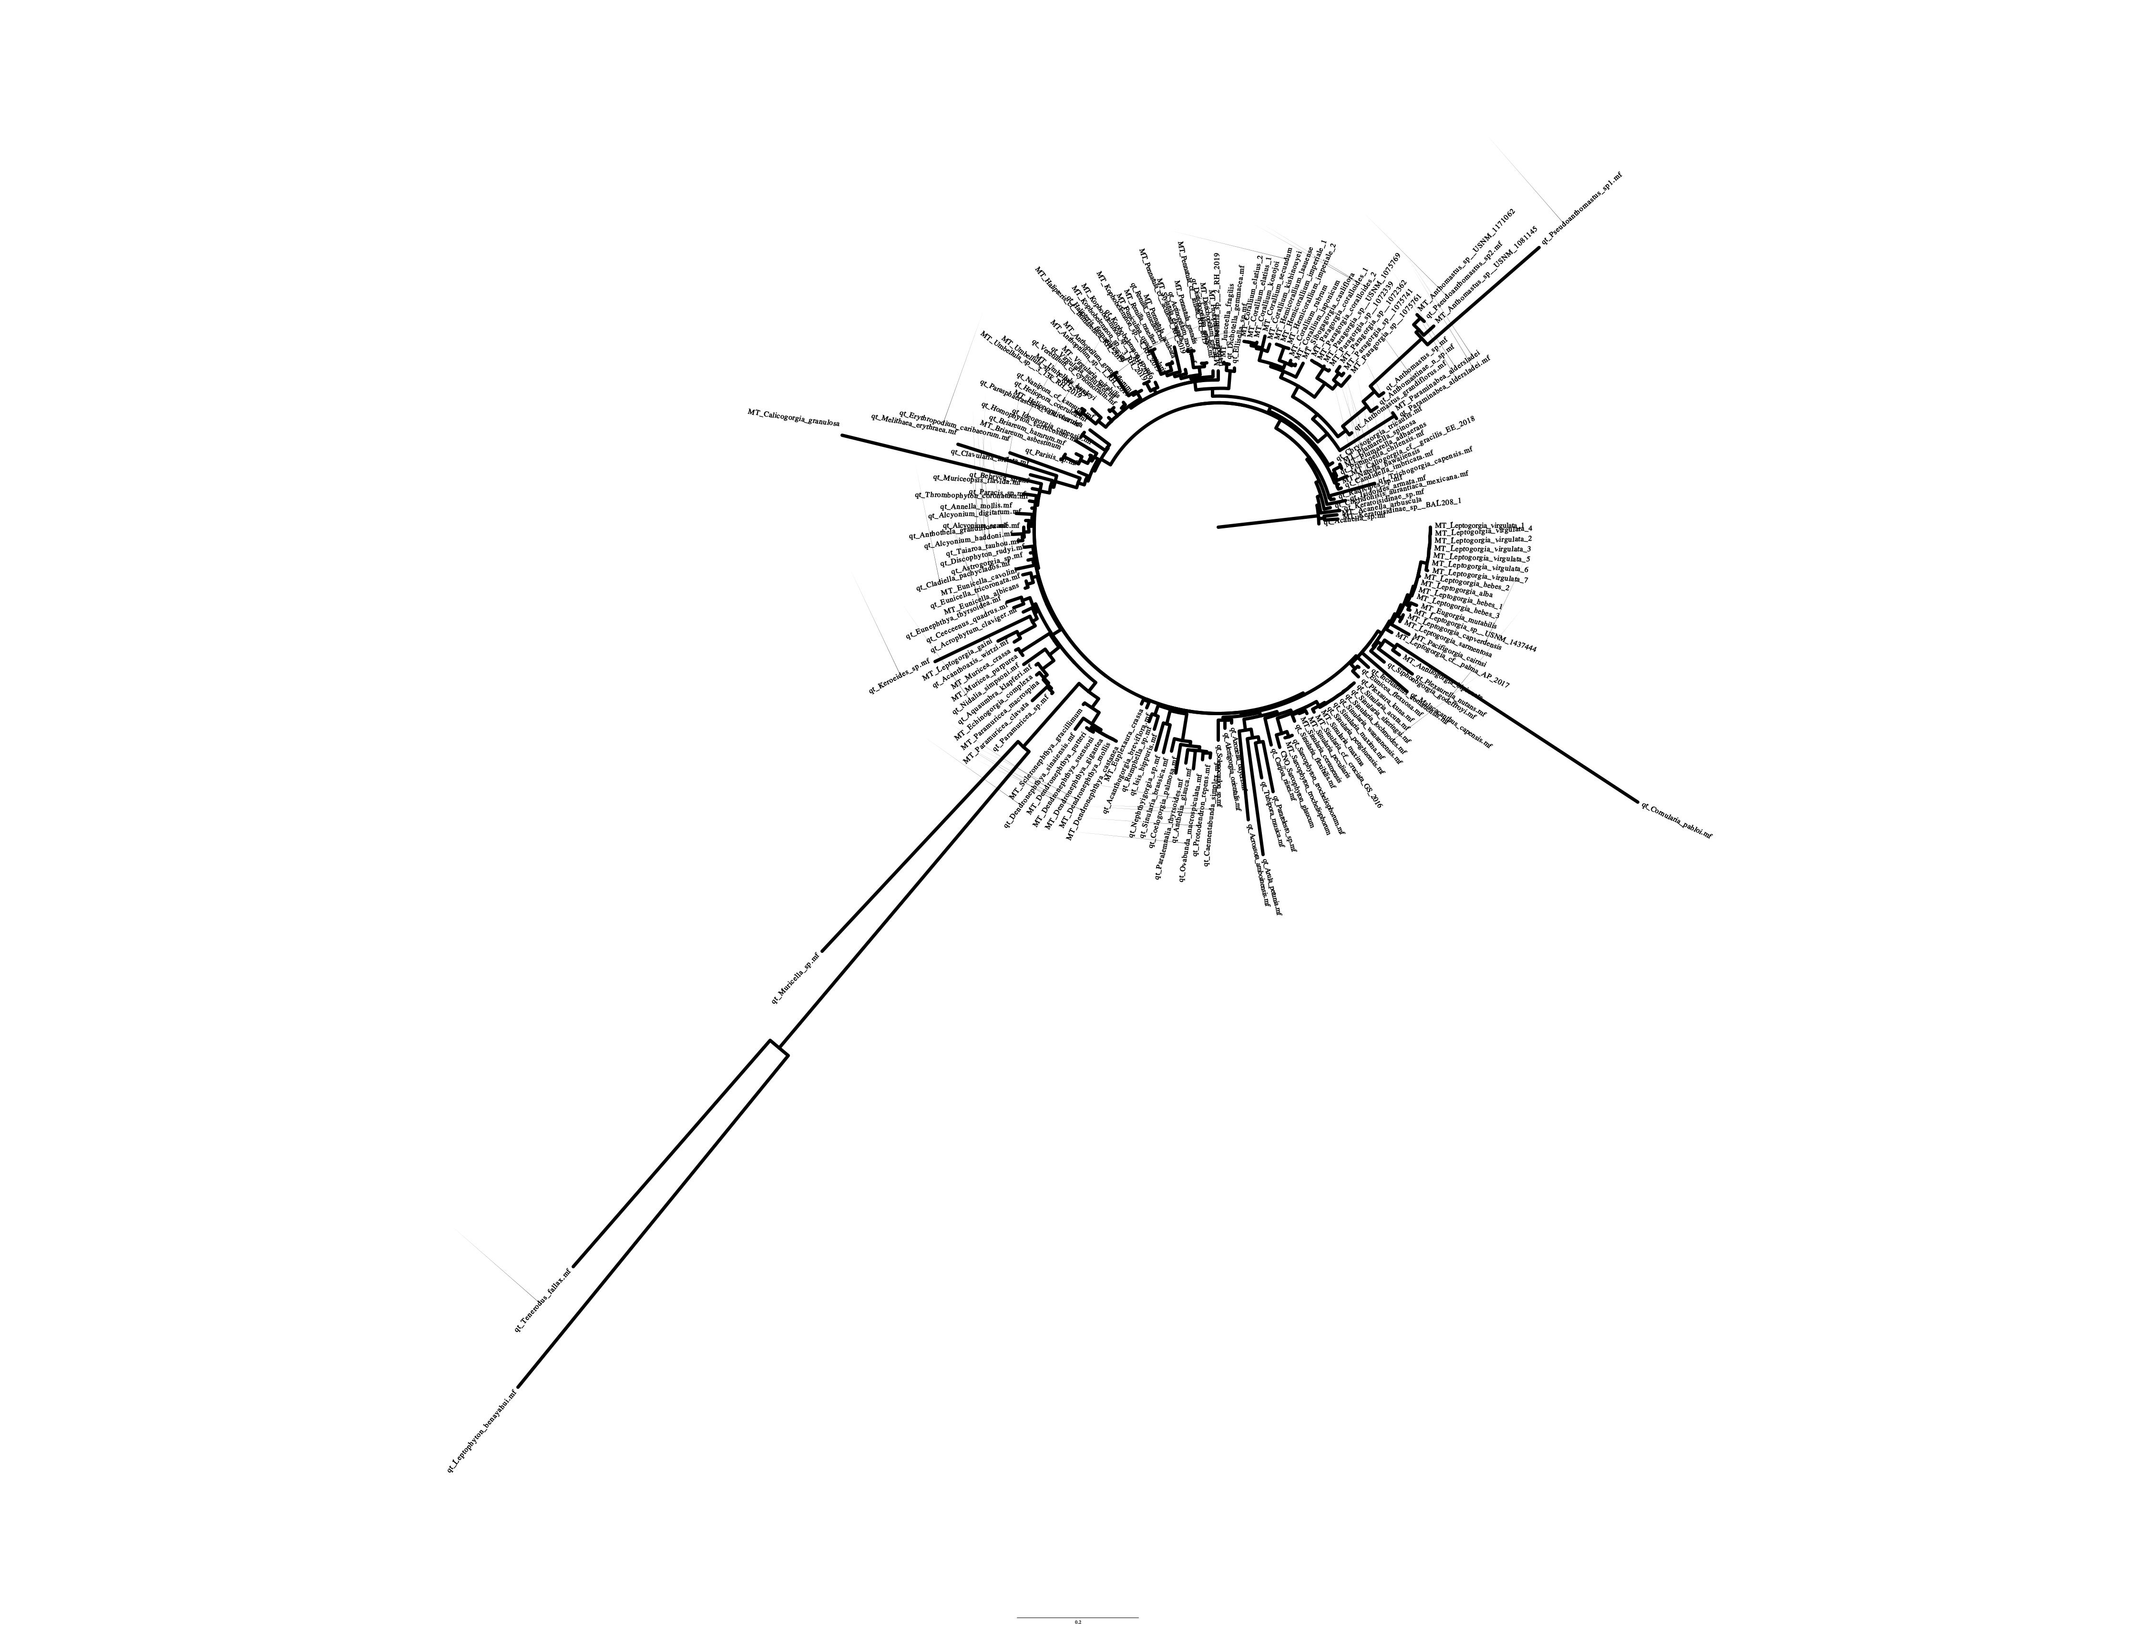Figure 15: NAD6 gene tree with transformed branch lengths (left) and distance-based branch lengths (right).

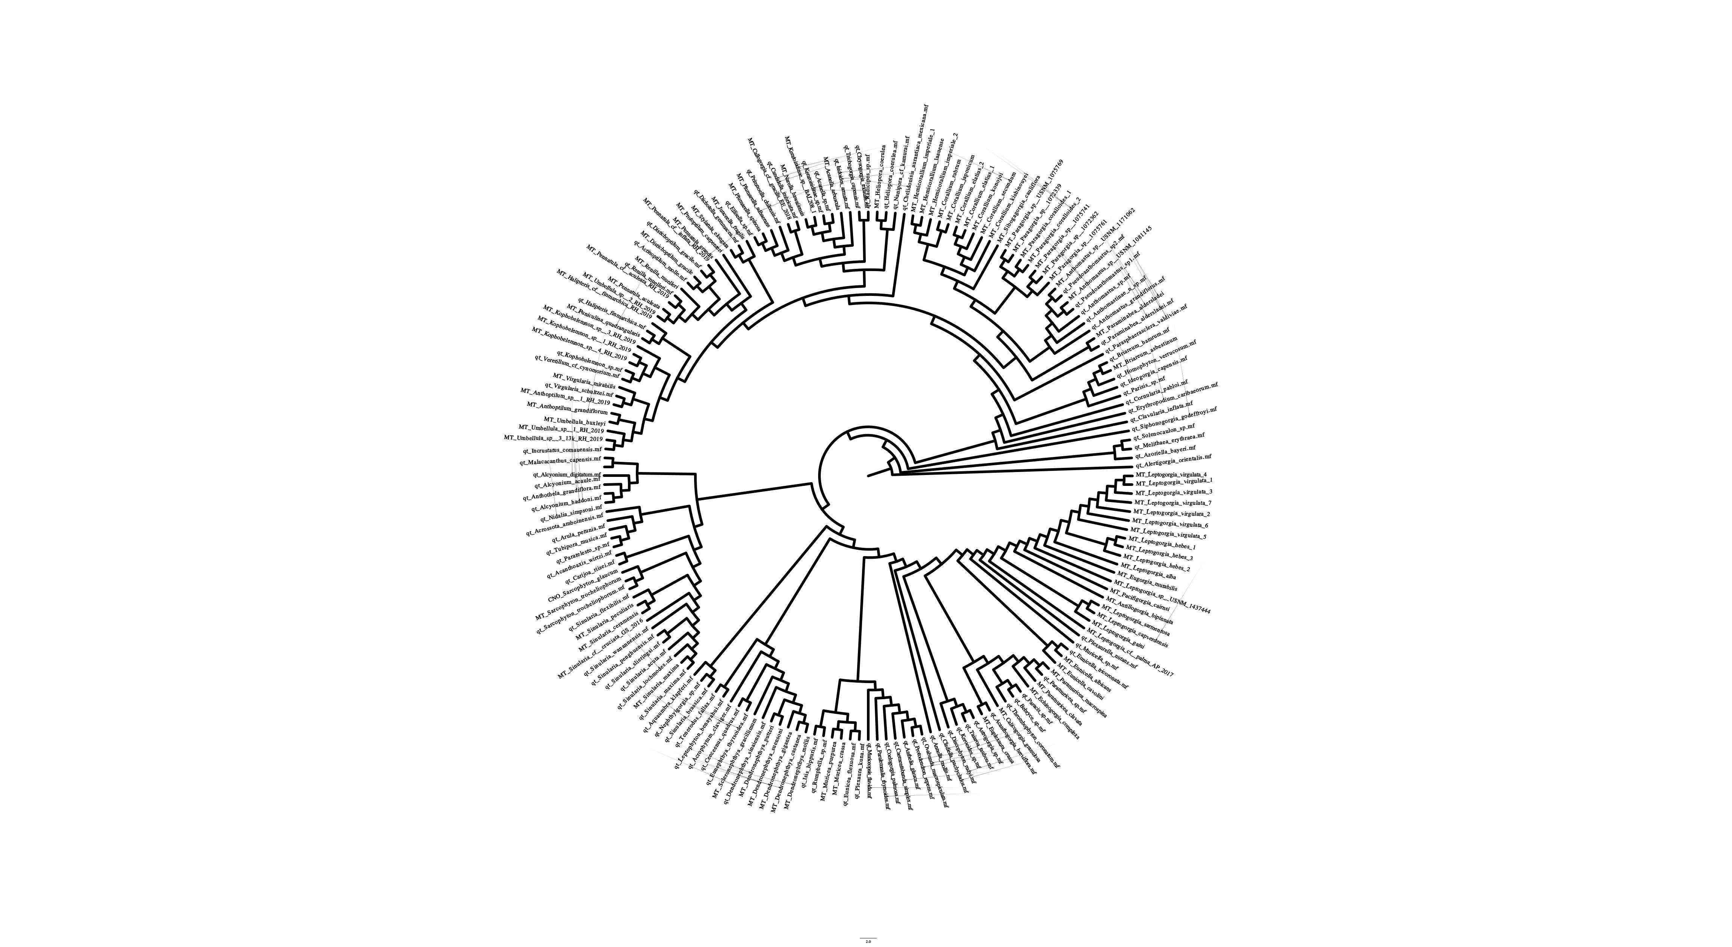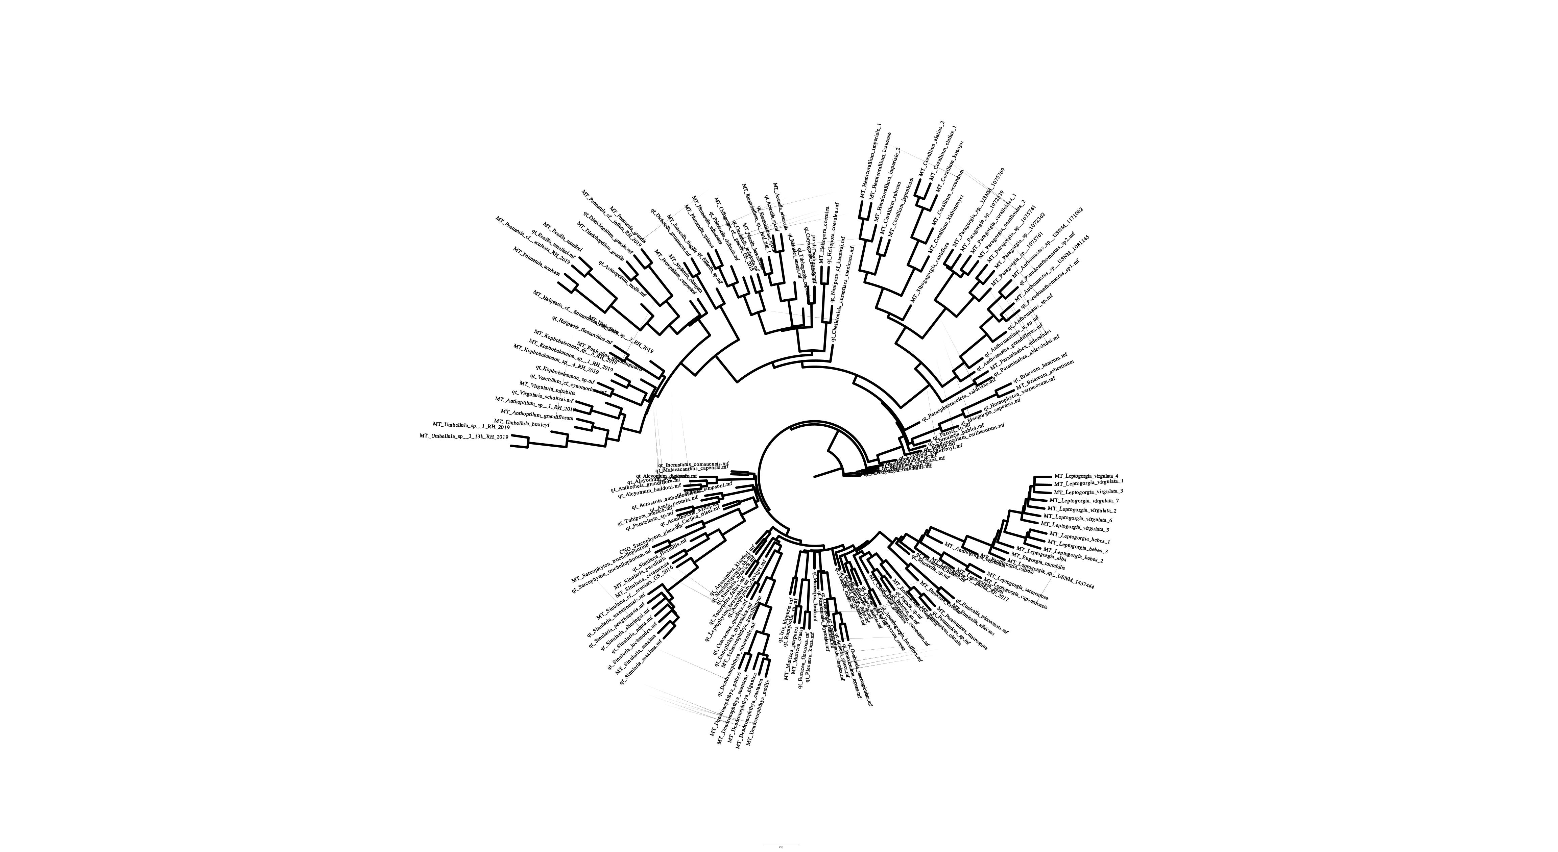Figure 16: SuperTree gene tree with transformed branch lengths (left) and distance-based branch lengths (right). This matches none of the gene trees.

SuperMatrix

Upon visual inspection, the SuperMatrix aligned well with the gene trees, including sharing the same long branches. There are little to no similarities between the SuperMatrix and the SuperTree.

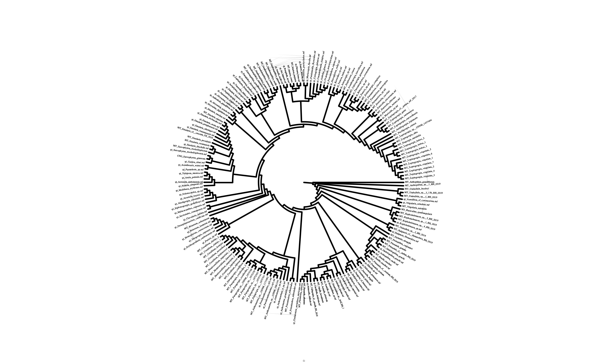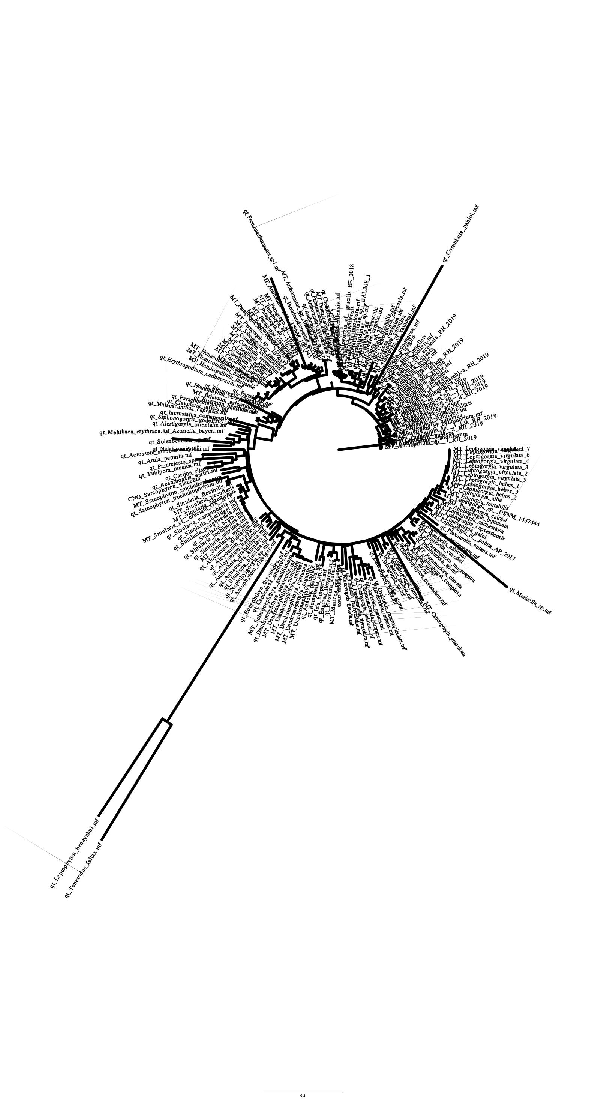

Figure 17: SuperMatrix Tree with transformed branch lengths (left) and distance-based branch lengths (right).

**Discussion**

The long branches found in both the gene trees and the SuperMatrix tree were highly surprising. The dataset consisted of 184 species and 14 loci, which should be large enough to account for long-branch attraction. The gene trees COX2 and mutS contained the shortest branch lengths. All gene trees contained a highly similar topography that matched well with the SuperMatrix. The SuperTree topography was highly unique unto itself.

This difference in topology between super trees suggests that mtDNA is not inherited as a single unit, however, the SuperMatrix matching the gene trees suggests otherwise. The results may indicate there is an error in one of the SuperTrees.

**Conclusion**

The results are highly ambiguous and need further testing. This may be due to the method of sequence concatenation being a custom python script. The current next steps include performing a baysian analysis on the data and following the same method to create protein trees for a more robust comparison. Further research into fasta concatenation programs is needed to test the viability of the current SuperMatrix.

**References**

[1] Duchêne, D. A. (2021). Phylogenomics. Current Biology, 31(19), R1177-R1181. <https://doi.org/10.1016/j.cub.2021.07.039>

[2] De Queiroz A., Gatesy J. (2007). The supermatrix approach to systematics. Trends in Ecology & Evolution, 22(1), 34-41, <https://doi.org/10.1016/j.tree.2006.10.002>.

[Moritz, C., Dowling, T. E., & Brown, W. M. (1987). EVOLUTION OF ANIMAL MITOCHONDRIAL DNA: RELEVANCE FOR POPULATION BIOLOGY AND SYSTEMATICS. Annual Review of Ecology and Systematics, (18), <https://doi.org/10.1146/annurev.es.18.110187.001413>

[4] Muthye V, Mackereth CD, Stewart JB, Lavrov DV. (2022) Large dataset of octocoral mitochondrial genomes provides new insights into mt-mutS evolution and function. DNA Repair (Amst). (110)103273. doi: 10.1016/j.dnarep.2022.103273. PMID: 35066390.

[5] Muthye, V., & Lavrov, D. (2021). Dataset for “Large dataset of octocoral mitochondrial genomes provides new insights into mt-mutS evolution and function.” <https://doi.org/10.17605/OSF.IO/JZT8X>

[6] Katoh K, Misawa K, Kuma K, Miyata T. (2002) MAFFT: a novel method for rapid multiple sequence alignment based on fast Fourier transform. Nucleic Acids Res. 30(14):3059-3066. doi:10.1093/nar/gkf436

[7] Kazutaka Katoh, Daron M. Standley, (2013) MAFFT Multiple Sequence Alignment Software Version 7: Improvements in Performance and Usability, Molecular Biology and Evolution, 30(4):772–780, <https://doi.org/10.1093/molbev/mst010>

[8] Alexey M Kozlov, Diego Darriba, Tomáš Flouri, Benoit Morel, Alexandros Stamatakis, (2019) RAxML-NG: a fast, scalable and user-friendly tool for maximum likelihood phylogenetic inference, Bioinformatics, 35(21):4453–4455, <https://doi.org/10.1093/bioinformatics/btz305>

[9] Rabiee, Maryam, Erfan Sayyari, and Siavash Mirarab. 2019. “Multi-Allele Species Reconstruction Using ASTRAL.” Molecular Phylogenetics and Evolution 130 (January). 286–96. [doi:10.1016/j.ympev.2018.10.033](https://doi.org/10.1016/j.ympev.2018.10.033).

[10] Rambaut A. (2018) FigTree v.1.4.4. <http://tree.bio.ed.ac.uk/software/figtree/>

[11] Timothy G Vaughan, IcyTree: rapid browser-based visualization for phylogenetic trees and networks, Bioinformatics, Volume 33, Issue 15, 01 August 2017, Pages 2392–2394, <https://doi.org/10.1093/bioinformatics/btx155>